Degree and Closeness Centrality

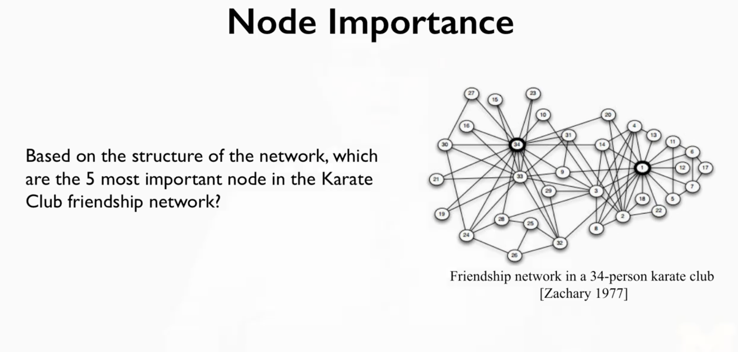

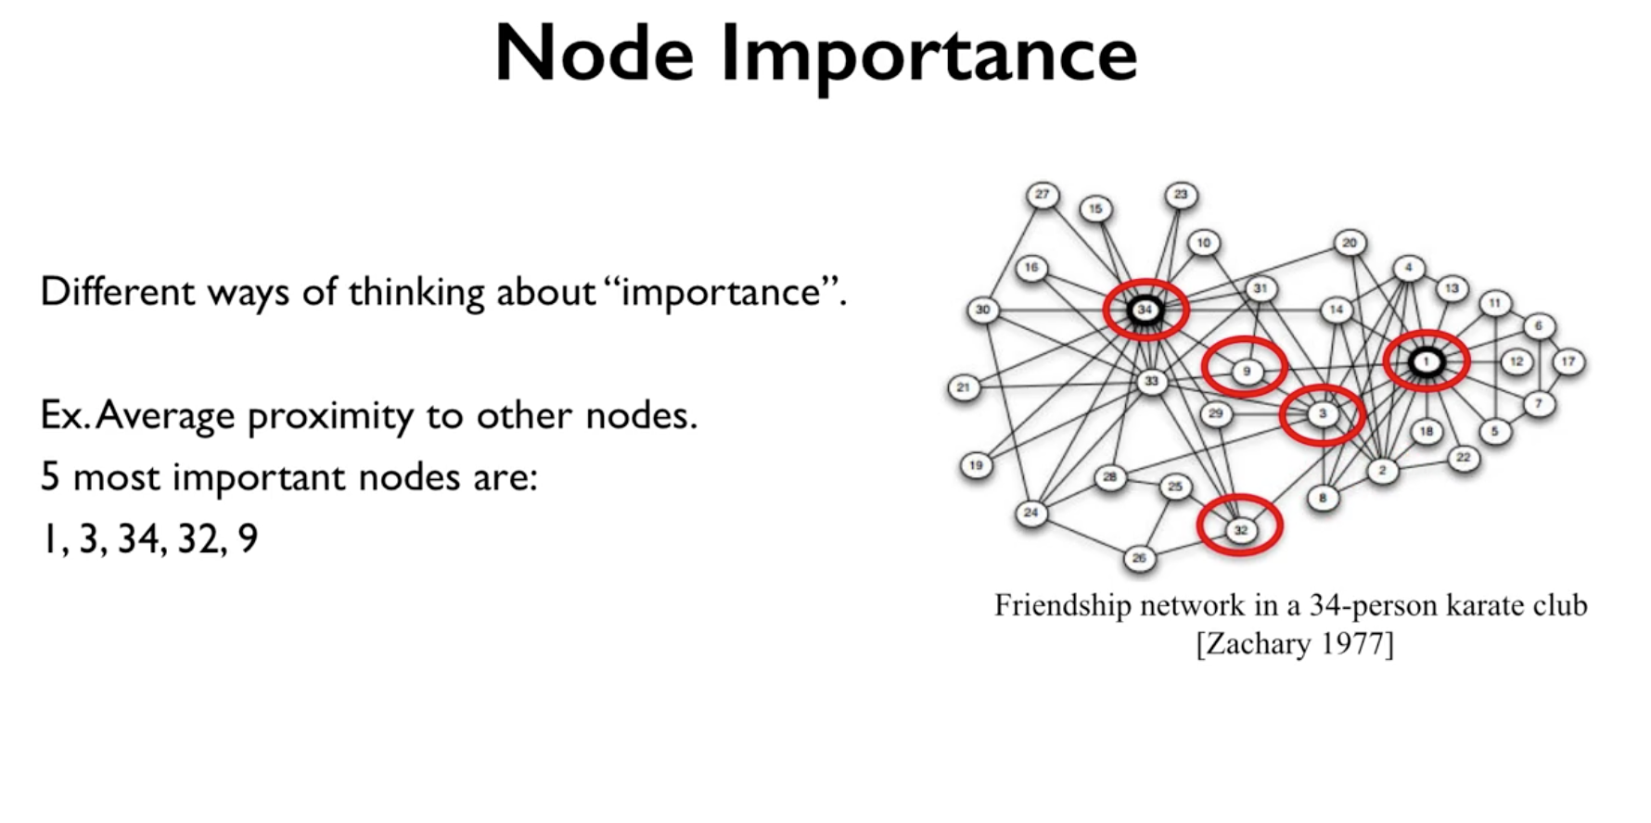

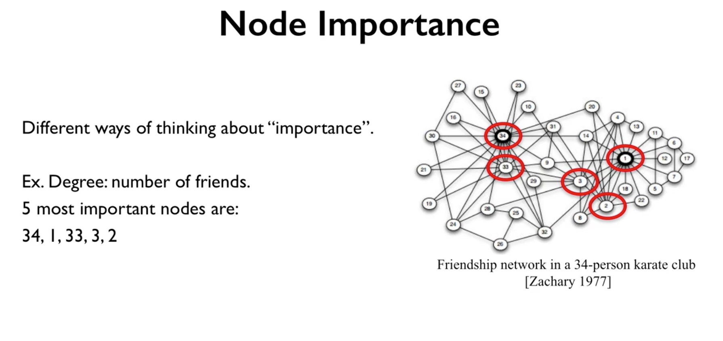

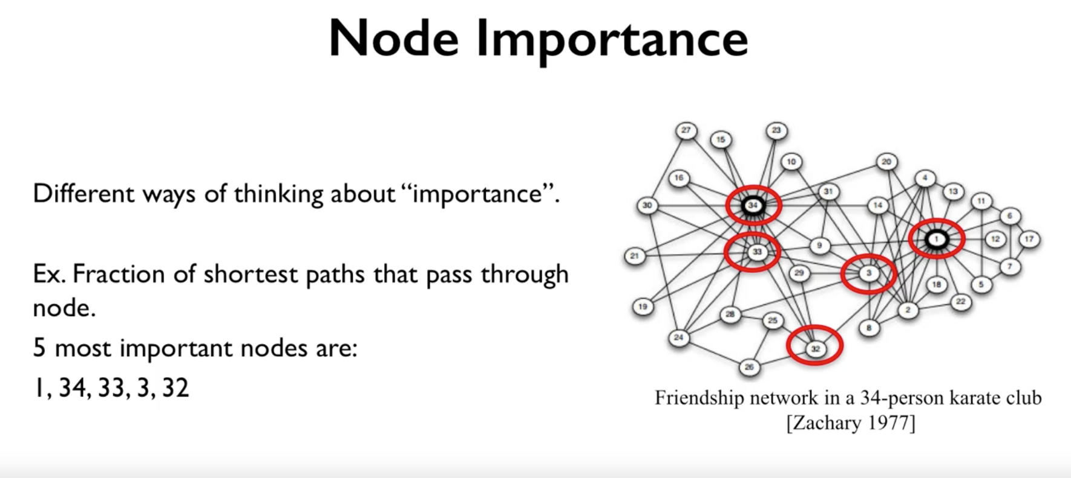

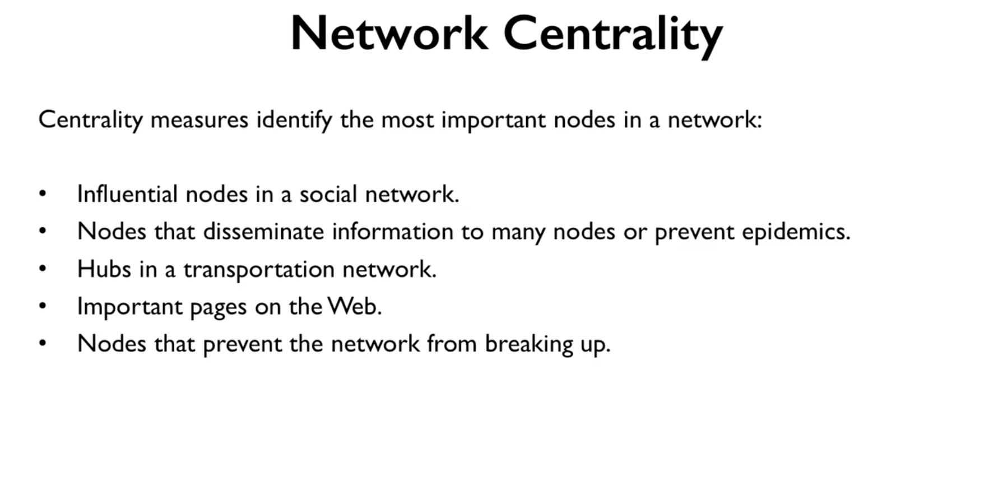

1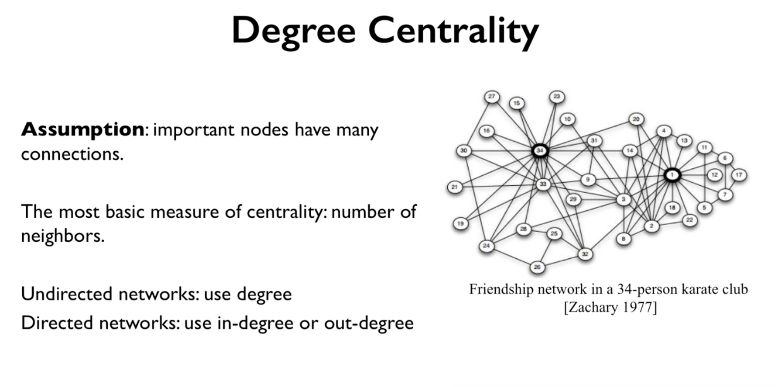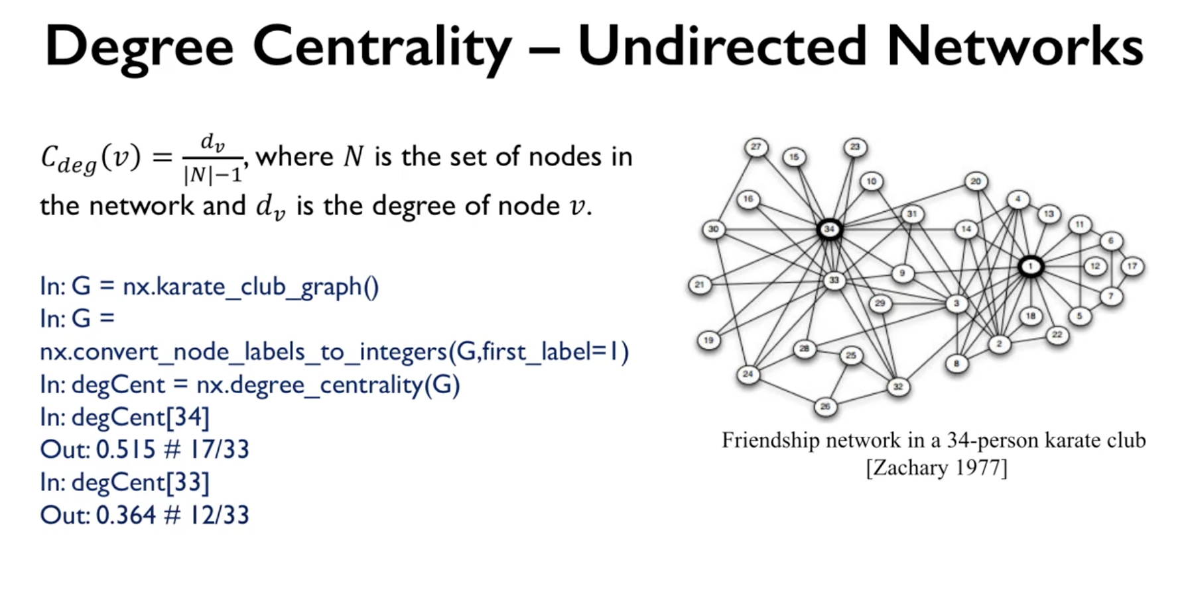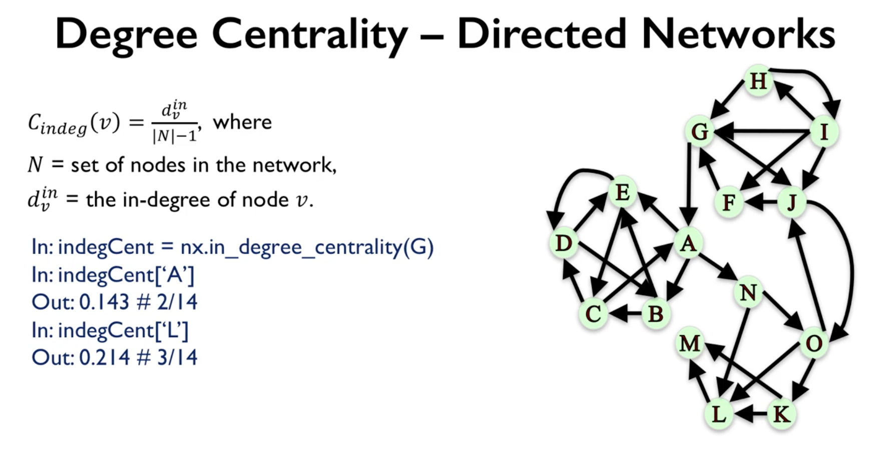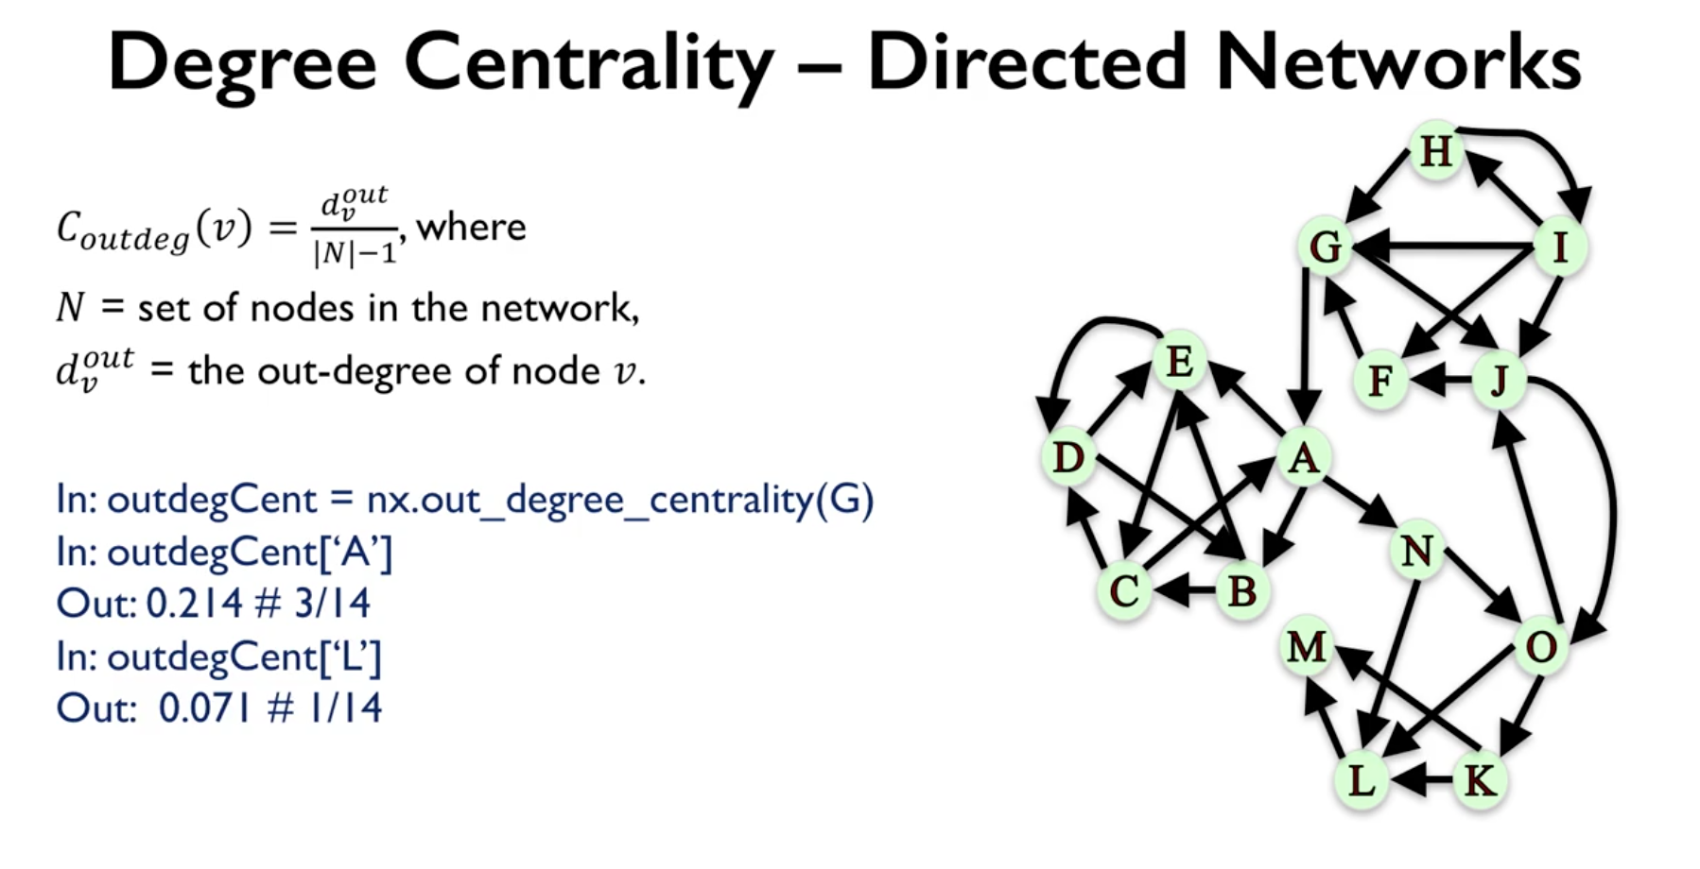

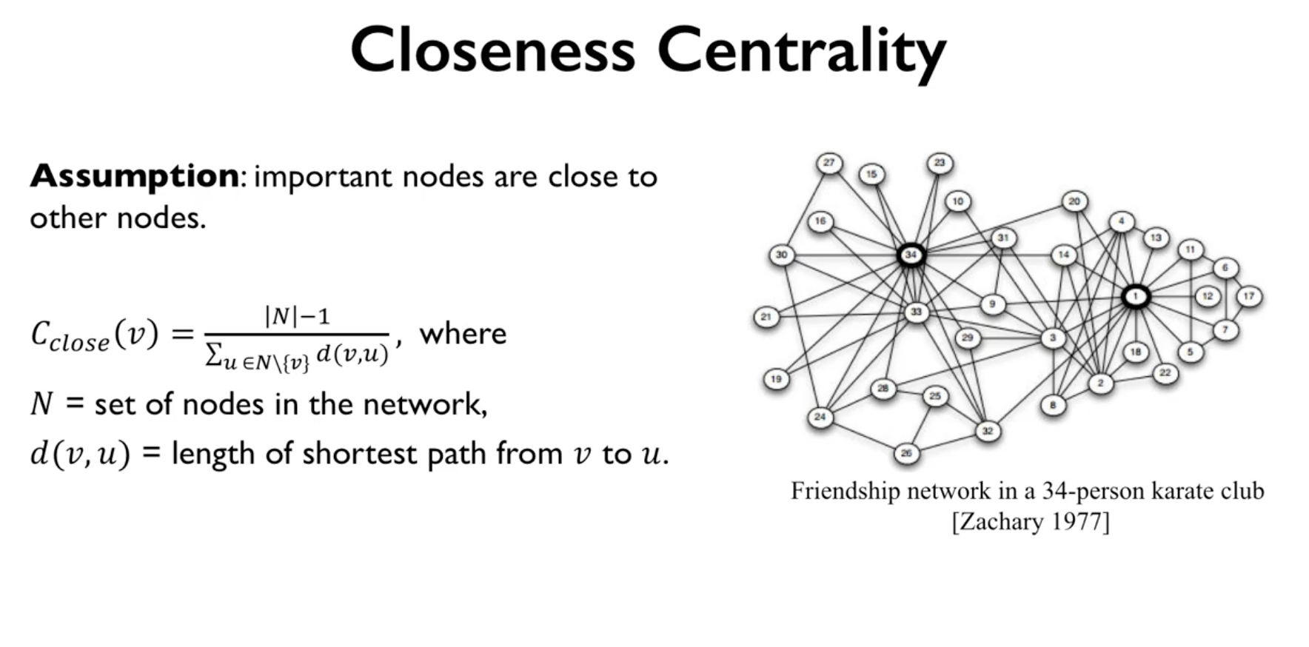

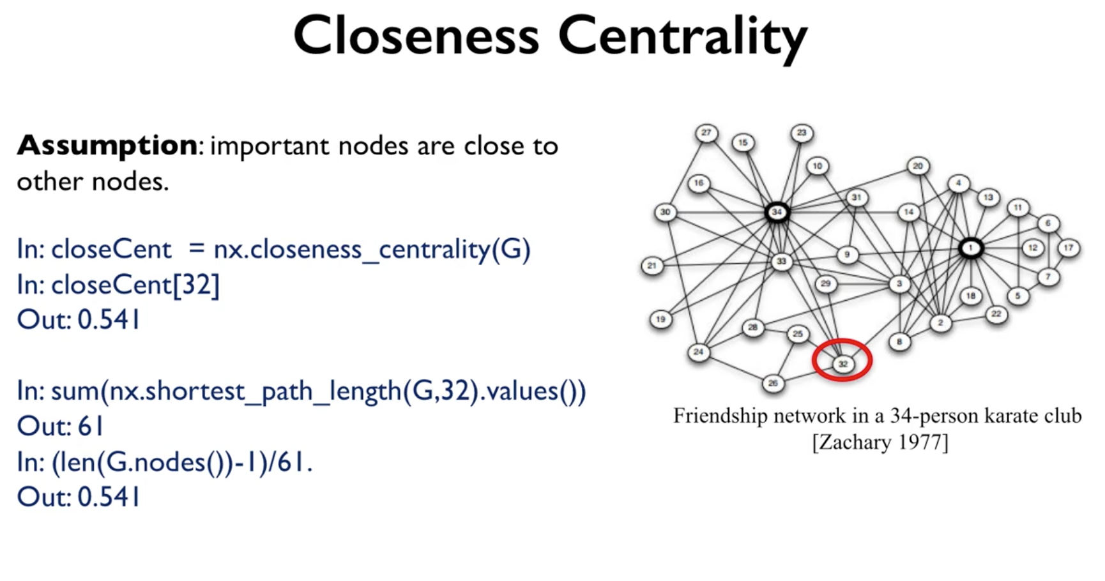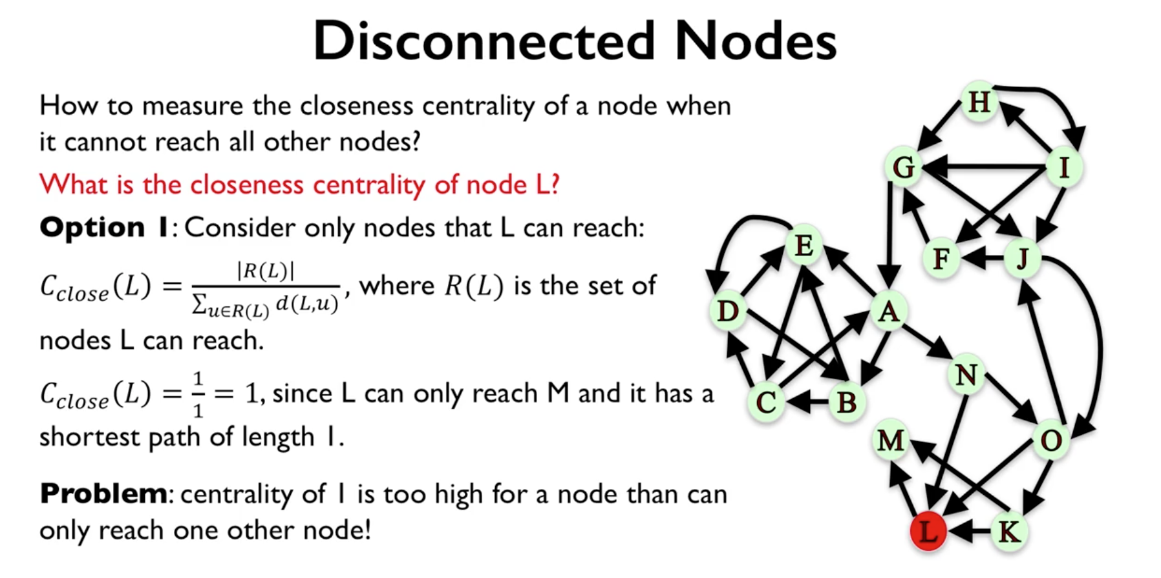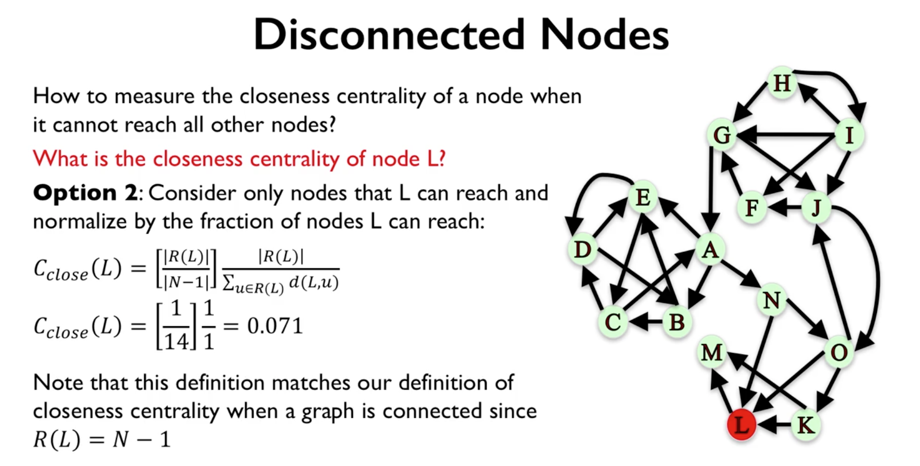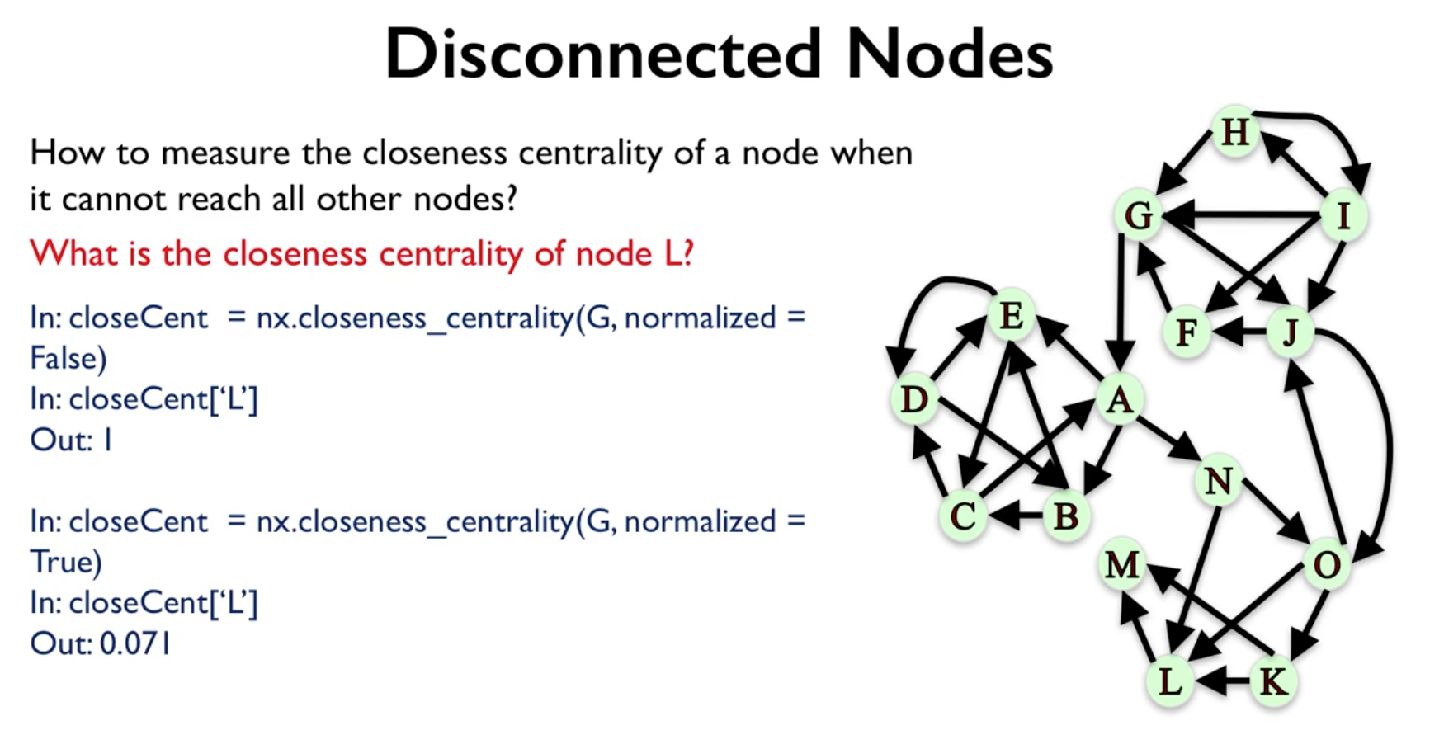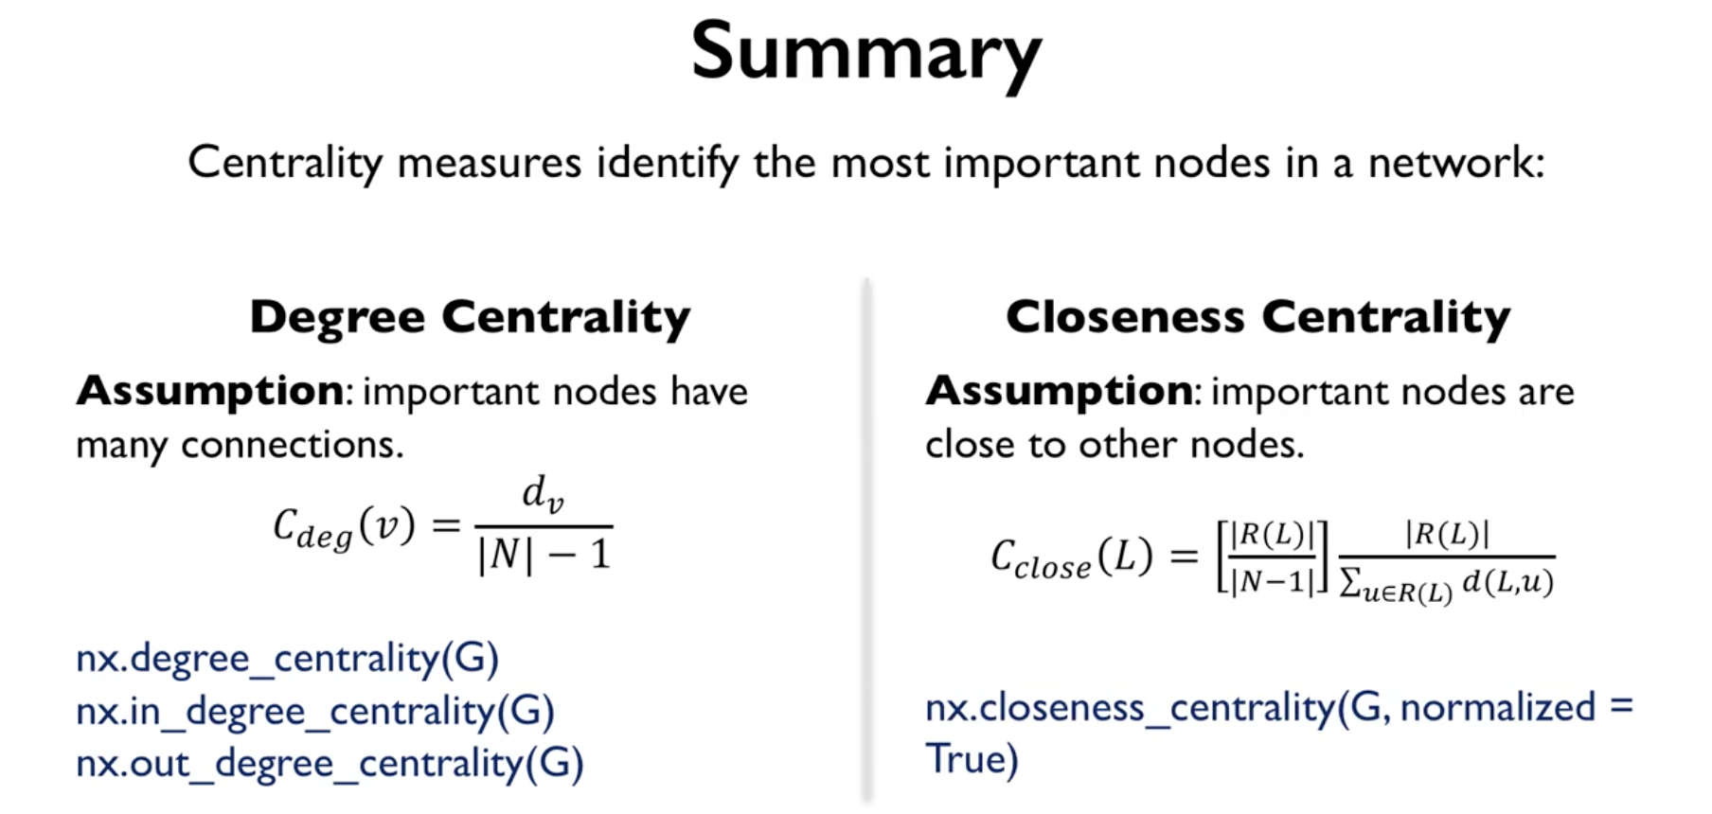

So, in summary, today we talked about centrality measures and how they aim to find the most important nodes in the network. We said that there are many many different ways of defining centrality and today we talked about two specific ones. A very basic definition of degree centrality which makes the assumption that important nodes are those who have many many connections, and we use this formula to measure the centrality of a node and it's simply the ratio between the degree of the node and the number of nodes in the graph minus one. And depending on whether we have a direct or undirected graph, we can use the degree of the node or the in-degree or the out-degree, and these are the different functions that you can use in network X to apply them. The second centrality measure that we looked at was closeness centrality and the assumption that it makes is that important nodes are close to other nodes. And here is the general formula that we use to compute it. And here, we can choose to normalize or not normalize as we discussed and the function that we use in network X to compute it is the function closeness centrality. This is it for this video and I hope to see you next time. Thanks.

Betweenness Centrality

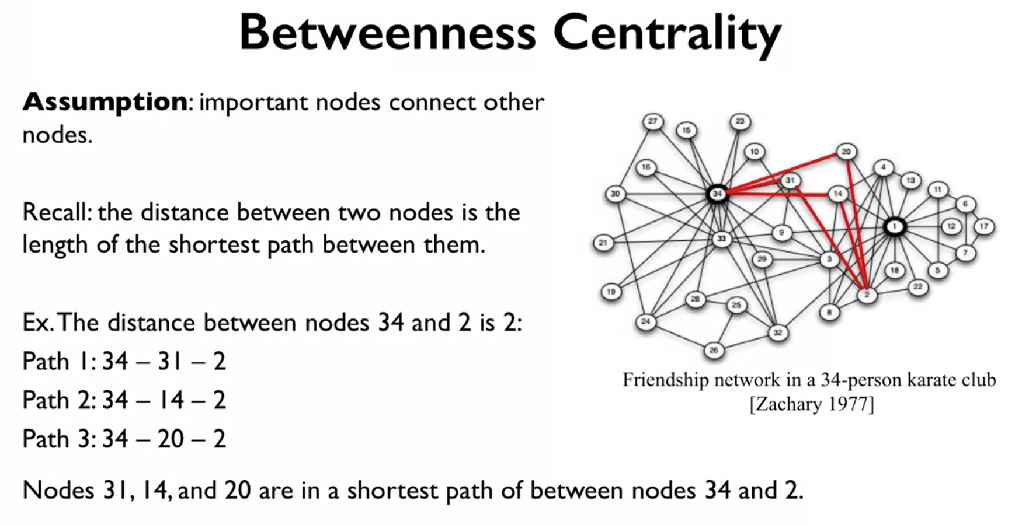

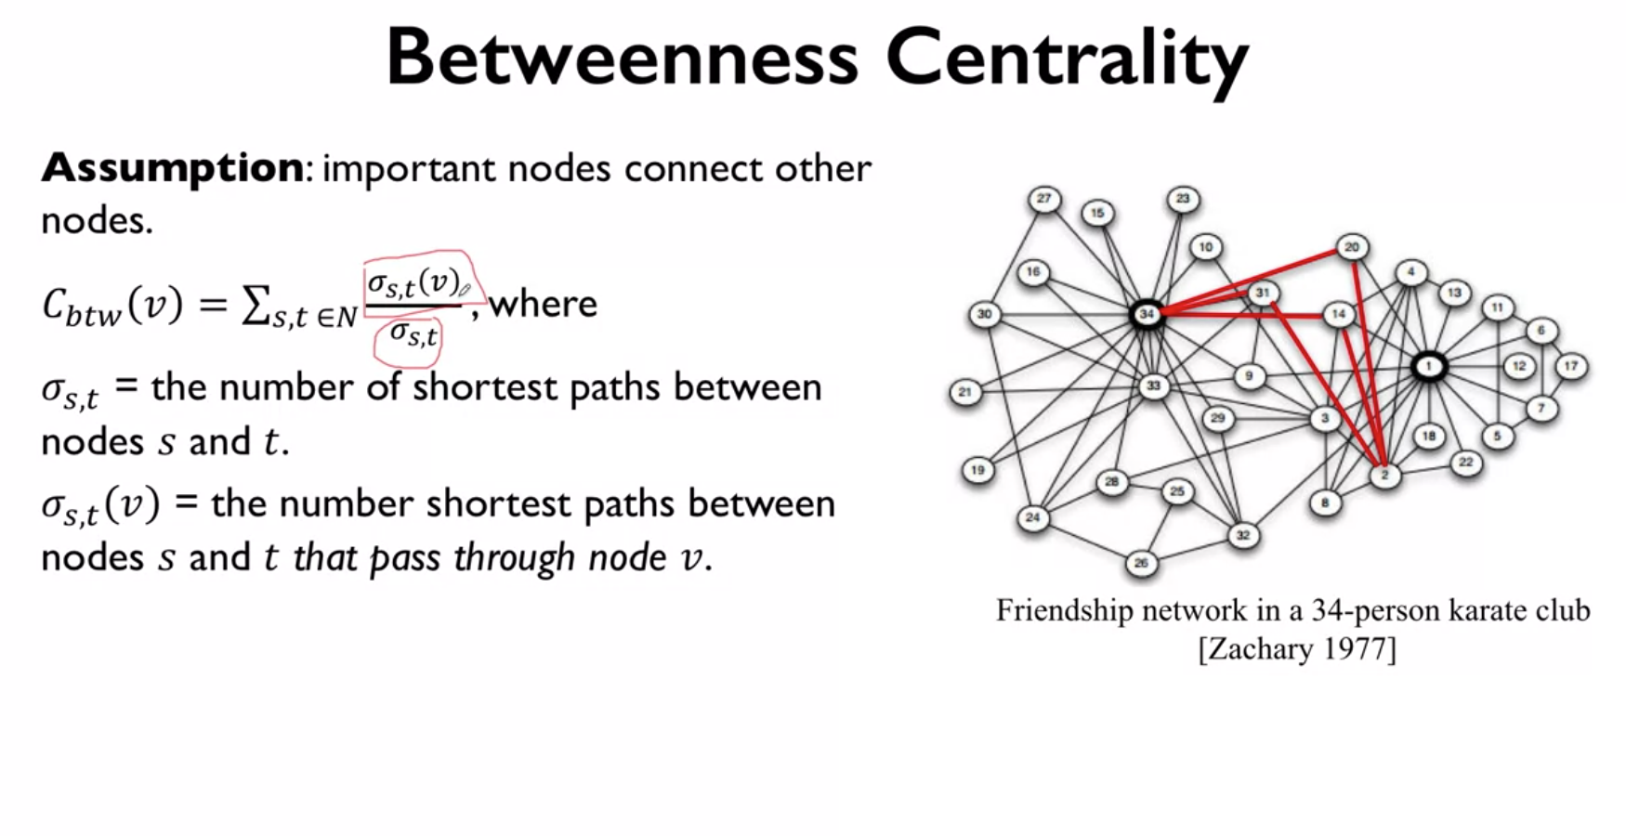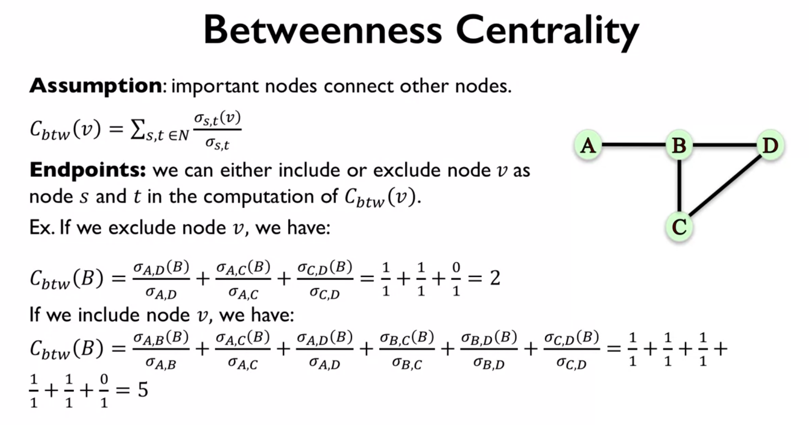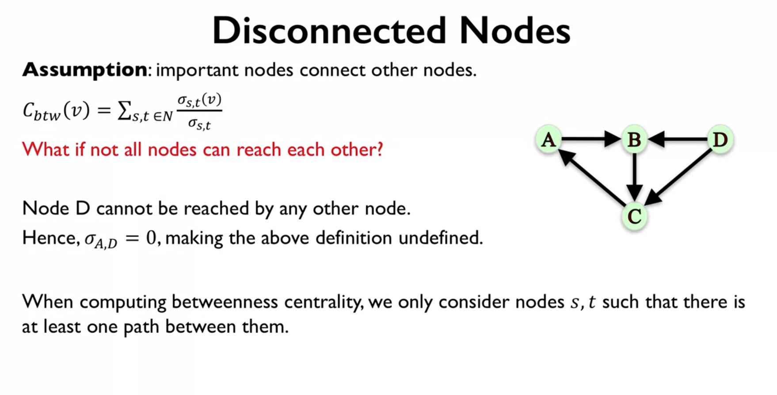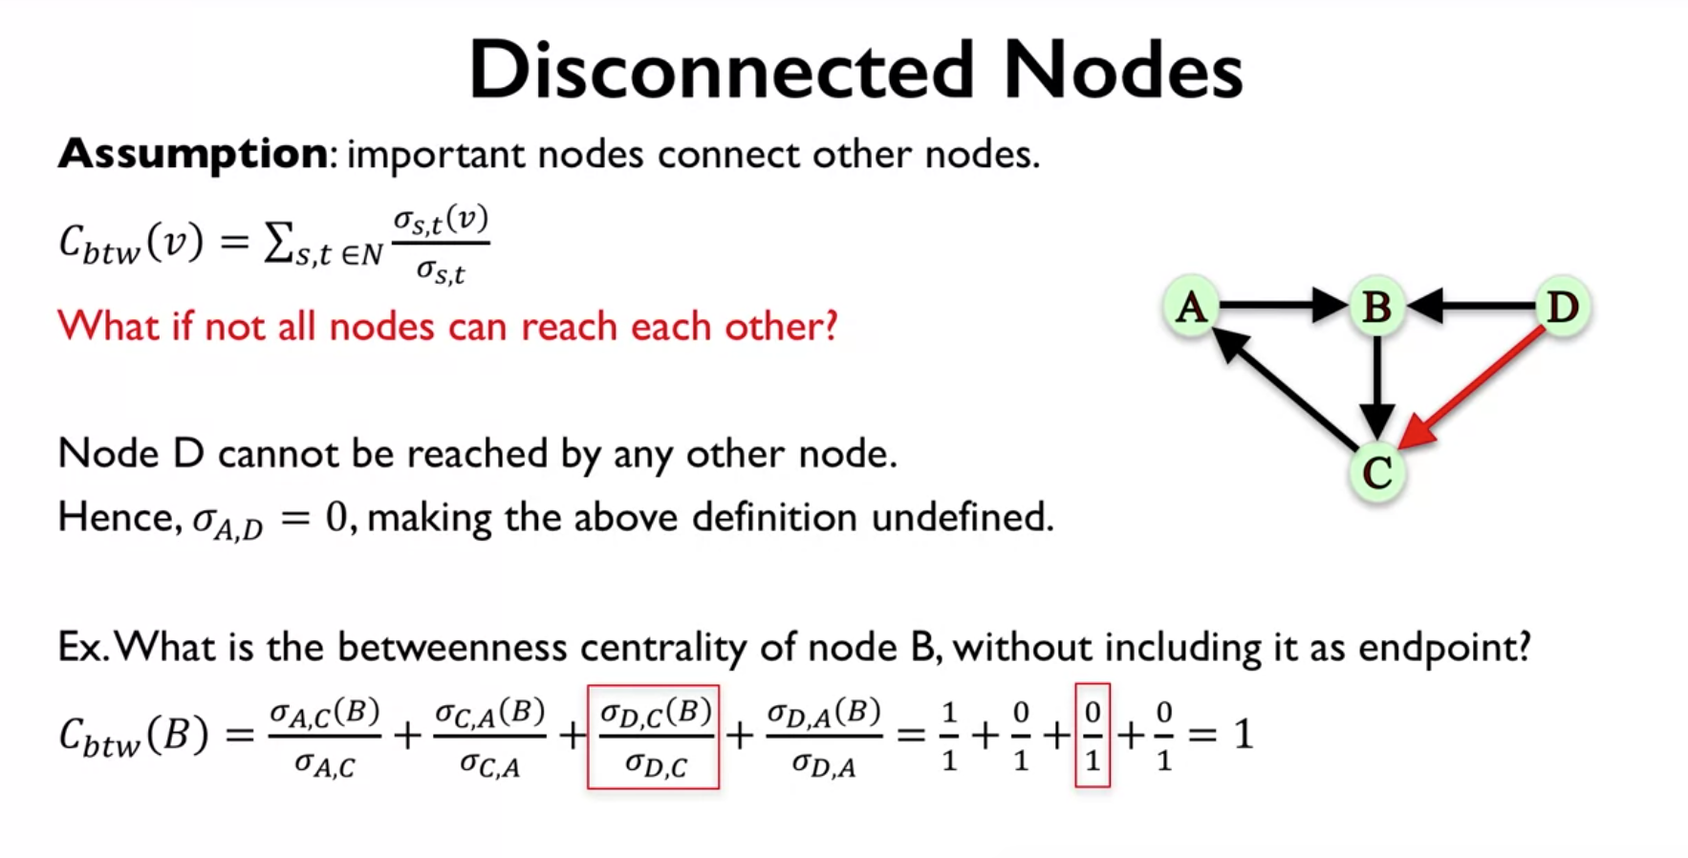

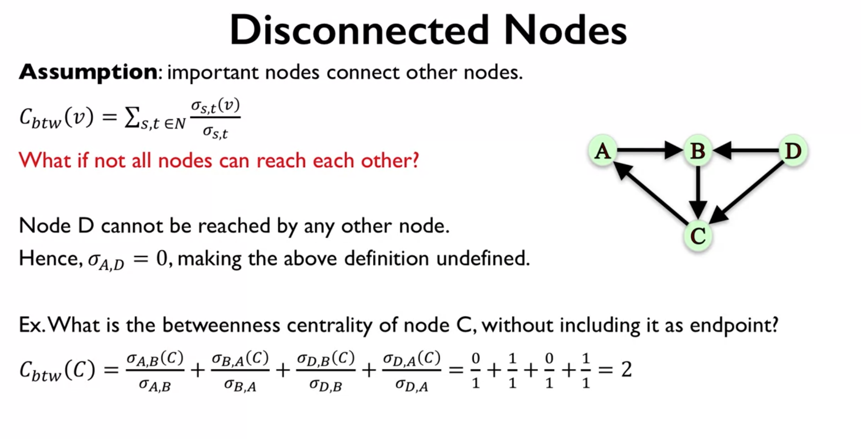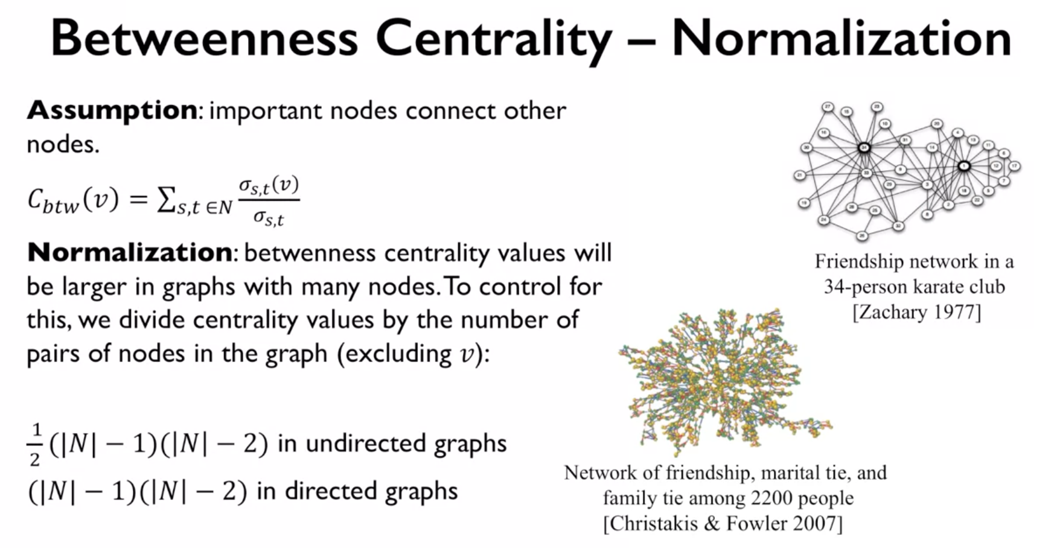

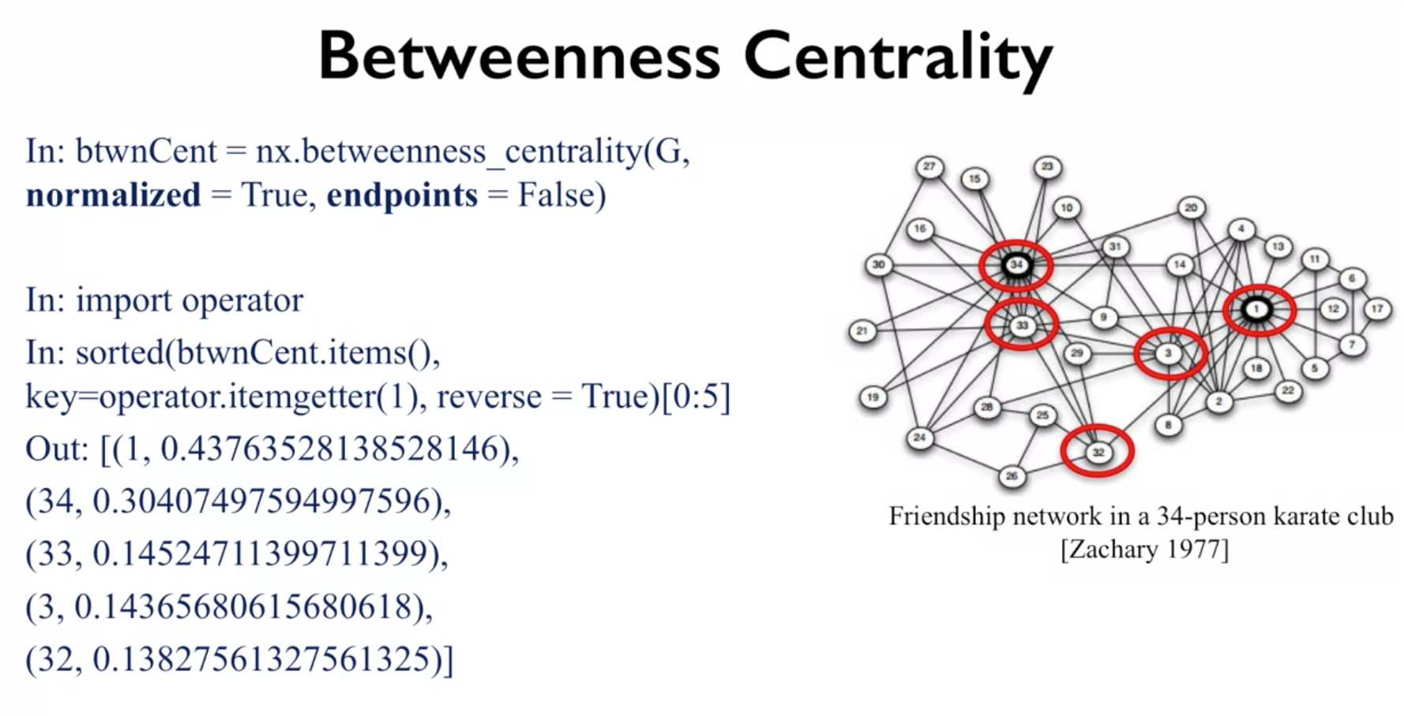

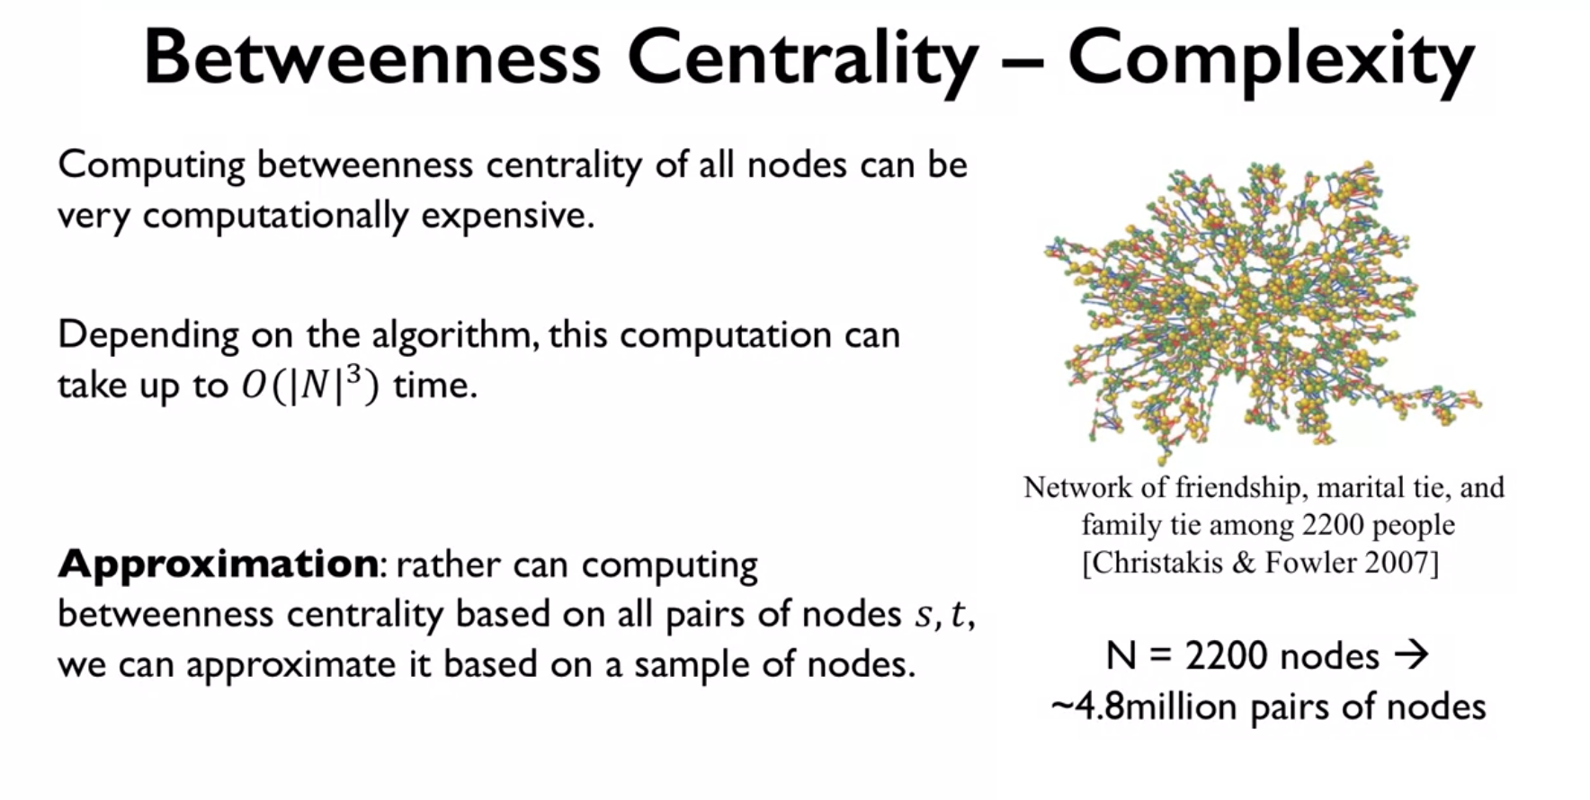

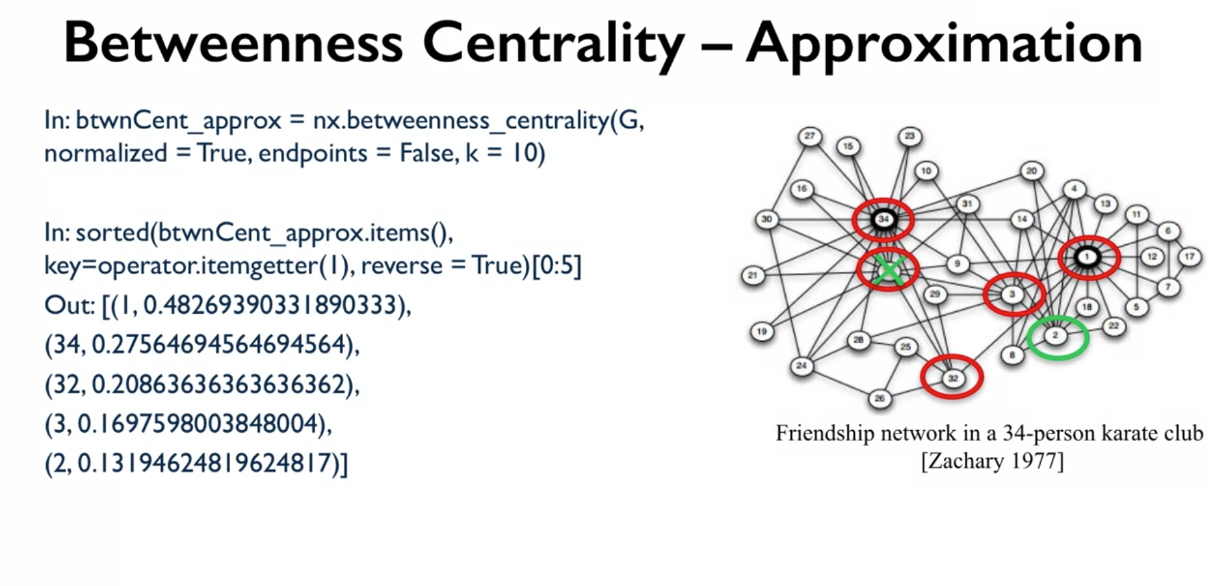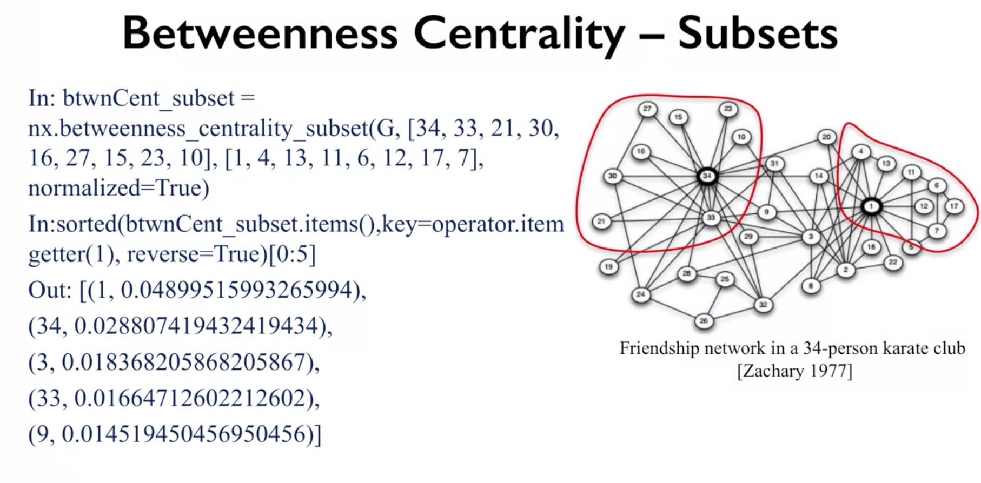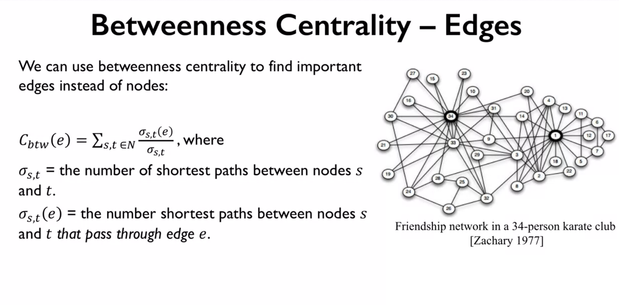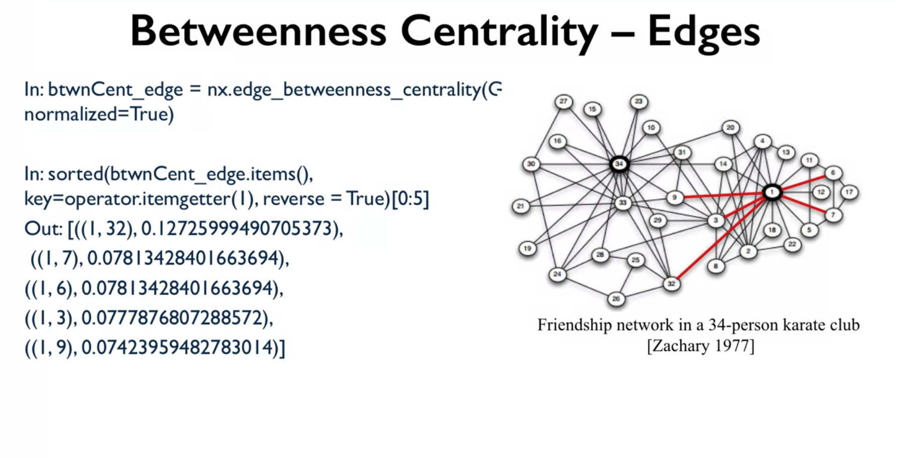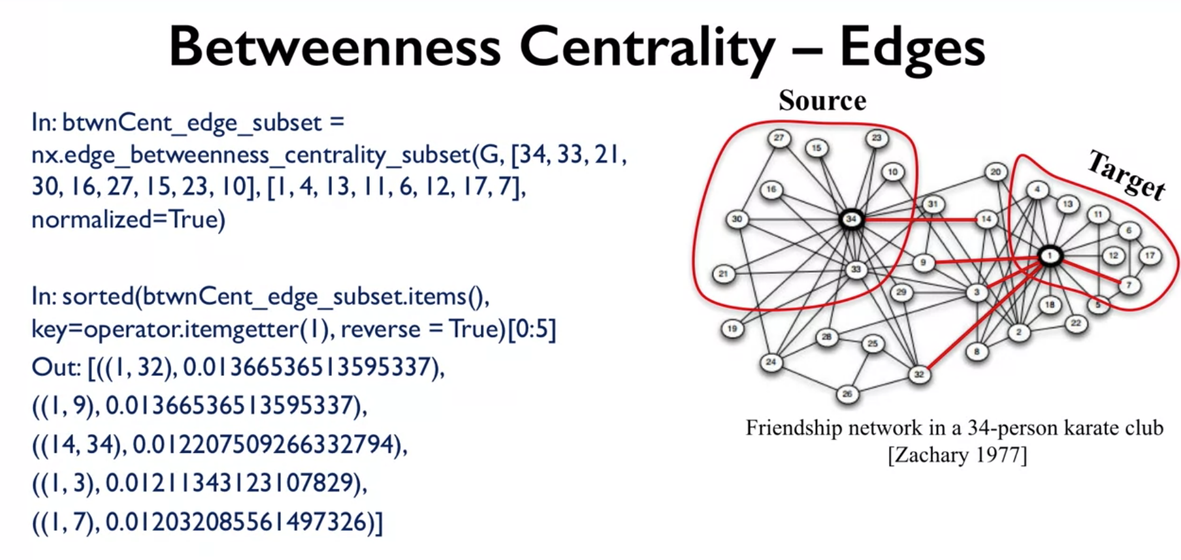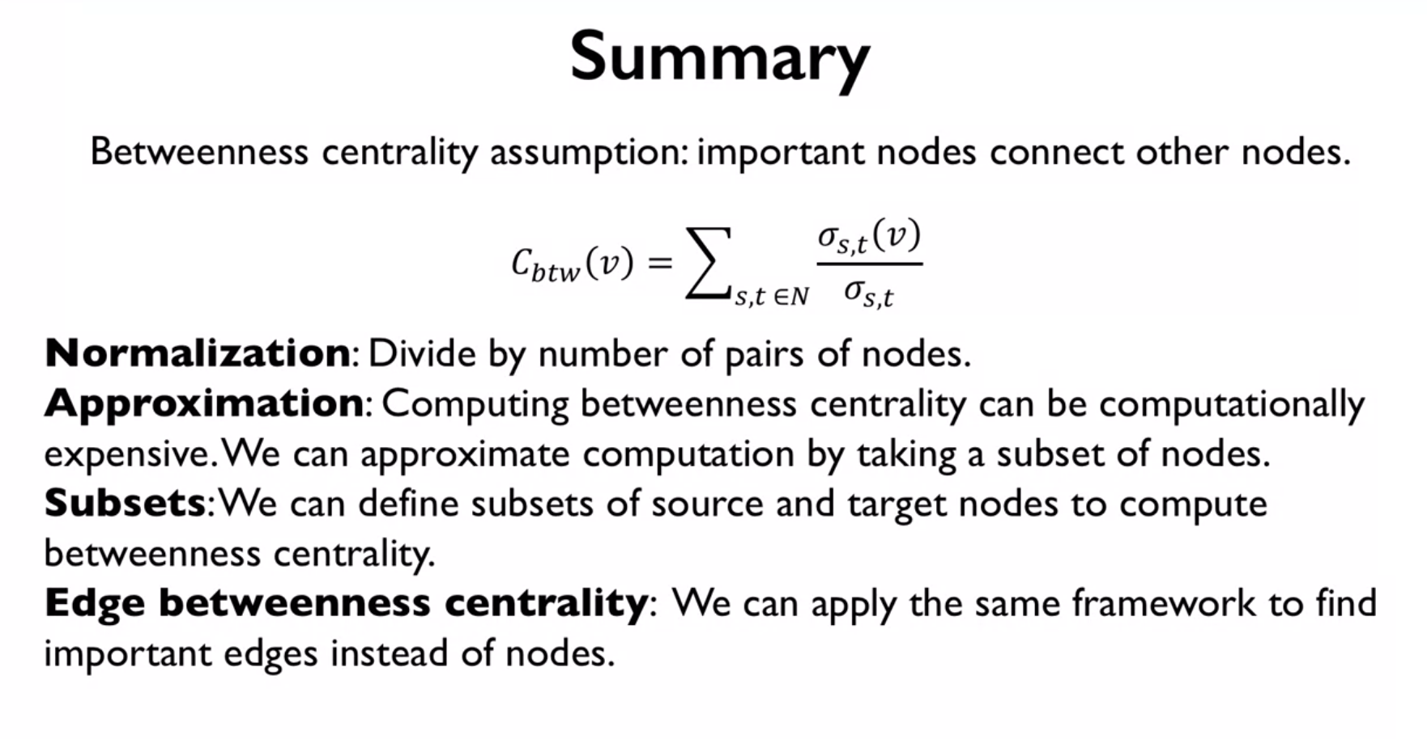

So in summary, we say that betweenness centrality makes the assumption that important nodes tend to connect the other nodes. And this is the formula that we use to compute it. In general, it's the sum of the fraction of the number of shortest paths that involve a particular node v divided by all the possible shortest paths between the nodes s and t. We talked about normalizing this, especially if we're comparing betweenness centrality among different networks of different sizes. So we divide by the number of pair of nodes. We also talked about approximating this because sometimes we're unable compute it exactly because it can be computationally expensive. So we can approximate it by selecting a subset of nodes rather than all the nodes. And we showed you how to do this in network x. We also talked about choosing specific sets of target nodes and specific sets of source nodes rather than using all possible pairs. That's if you have a particular sets of nodes that you care about and that you want to know, who are the important nodes that are connecting nodes in this two specific sets. And then we talked about how we can generalize this a bit more and talked about the betweenness centrality of not only the nodes but also the edges. Much in the same way that we define it for nodes, we can also define for edge. This is all for this video. Thank you for watching and I see you next time.

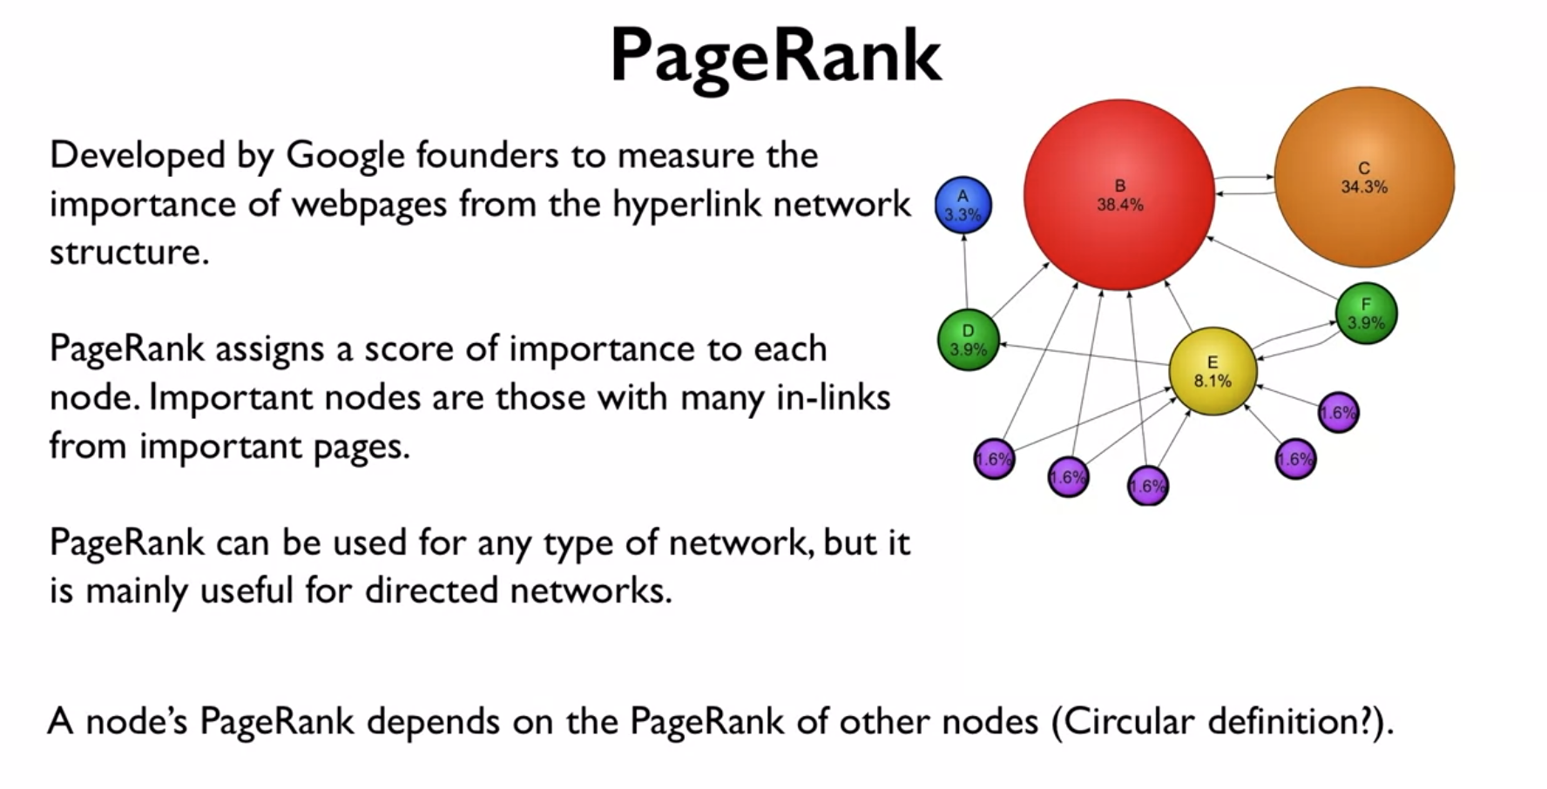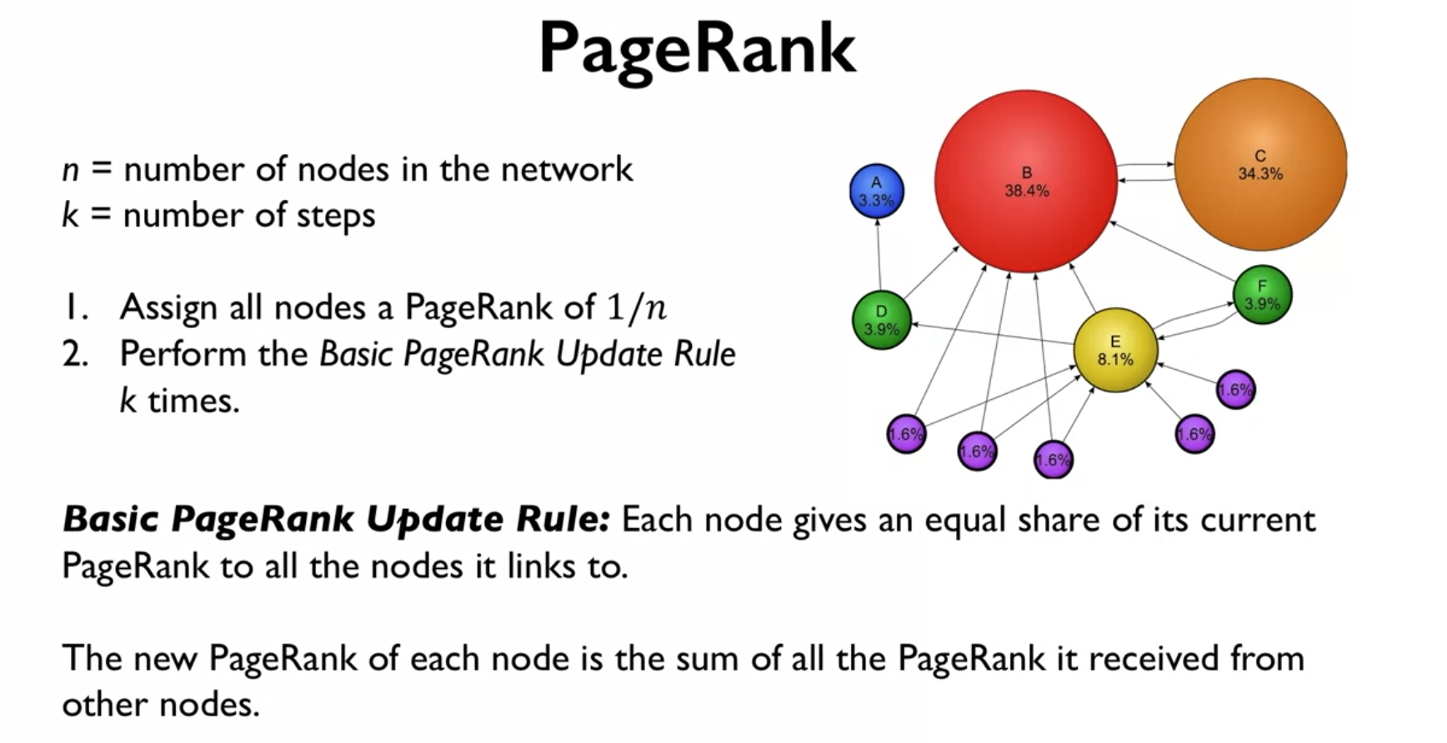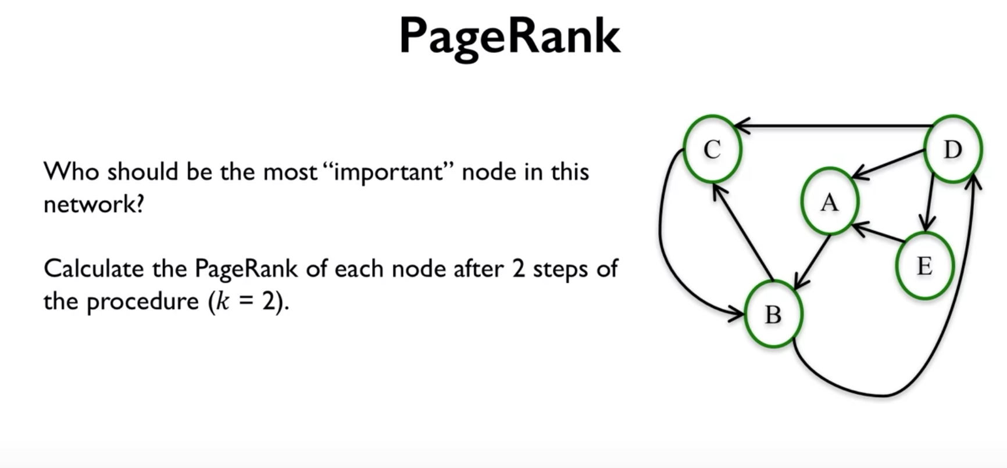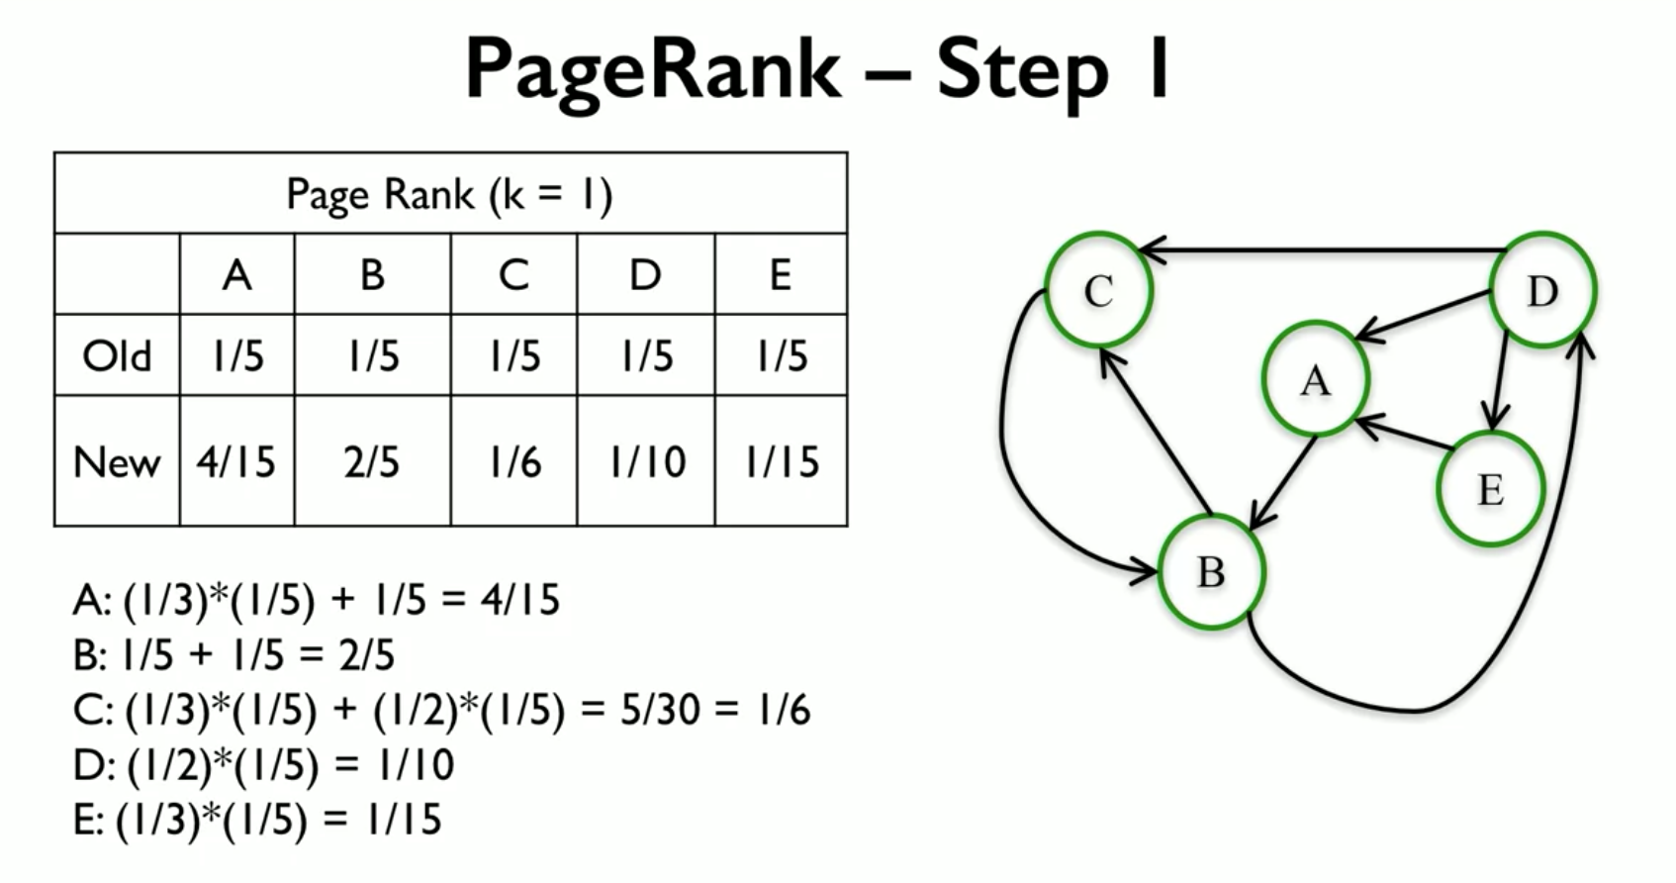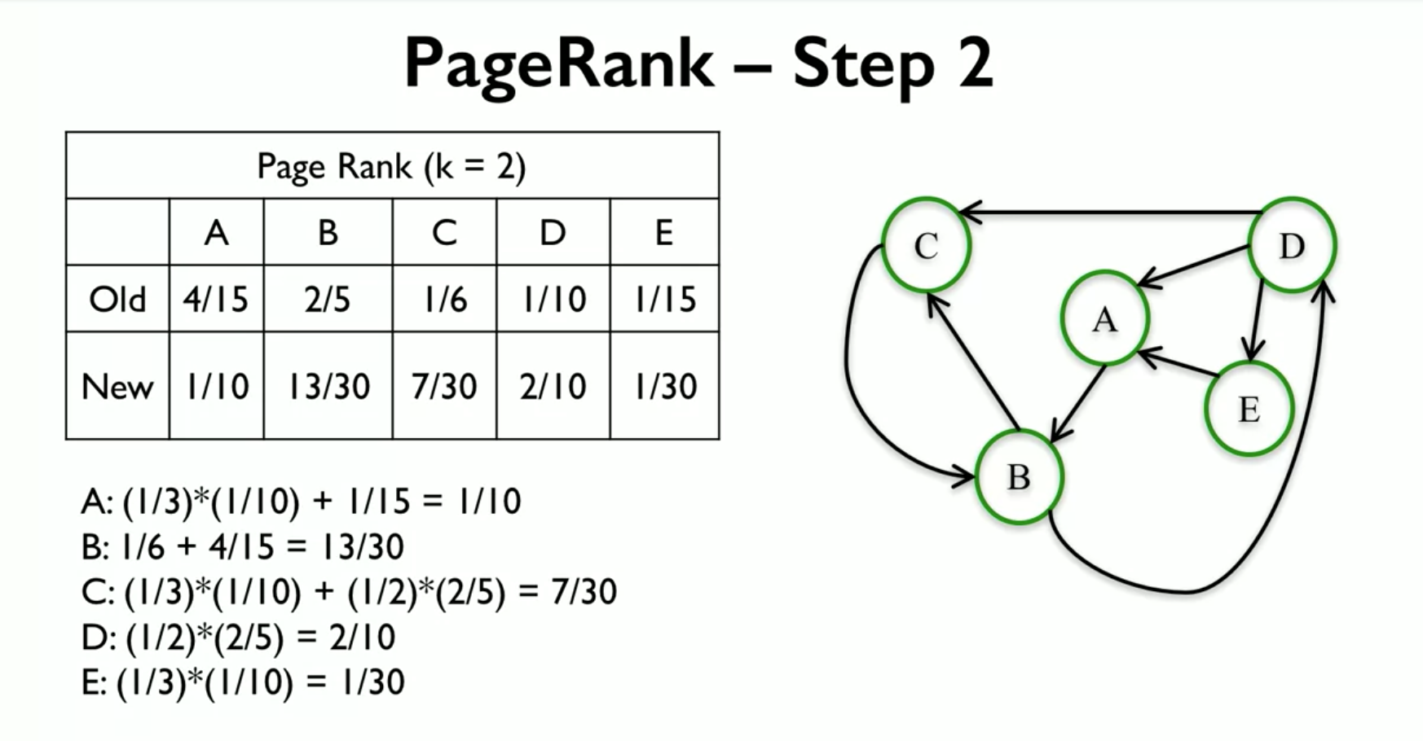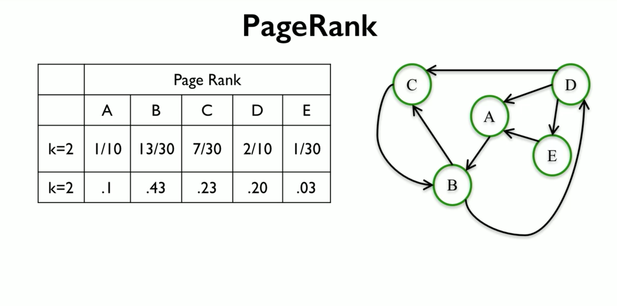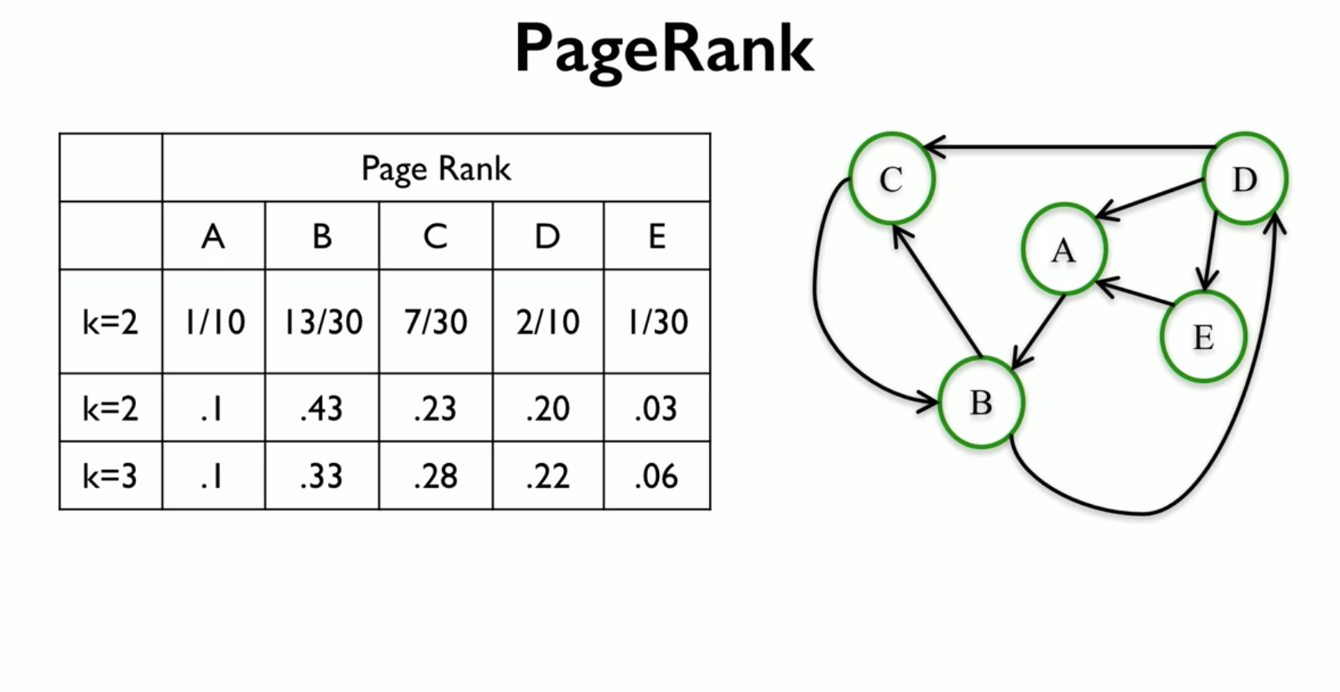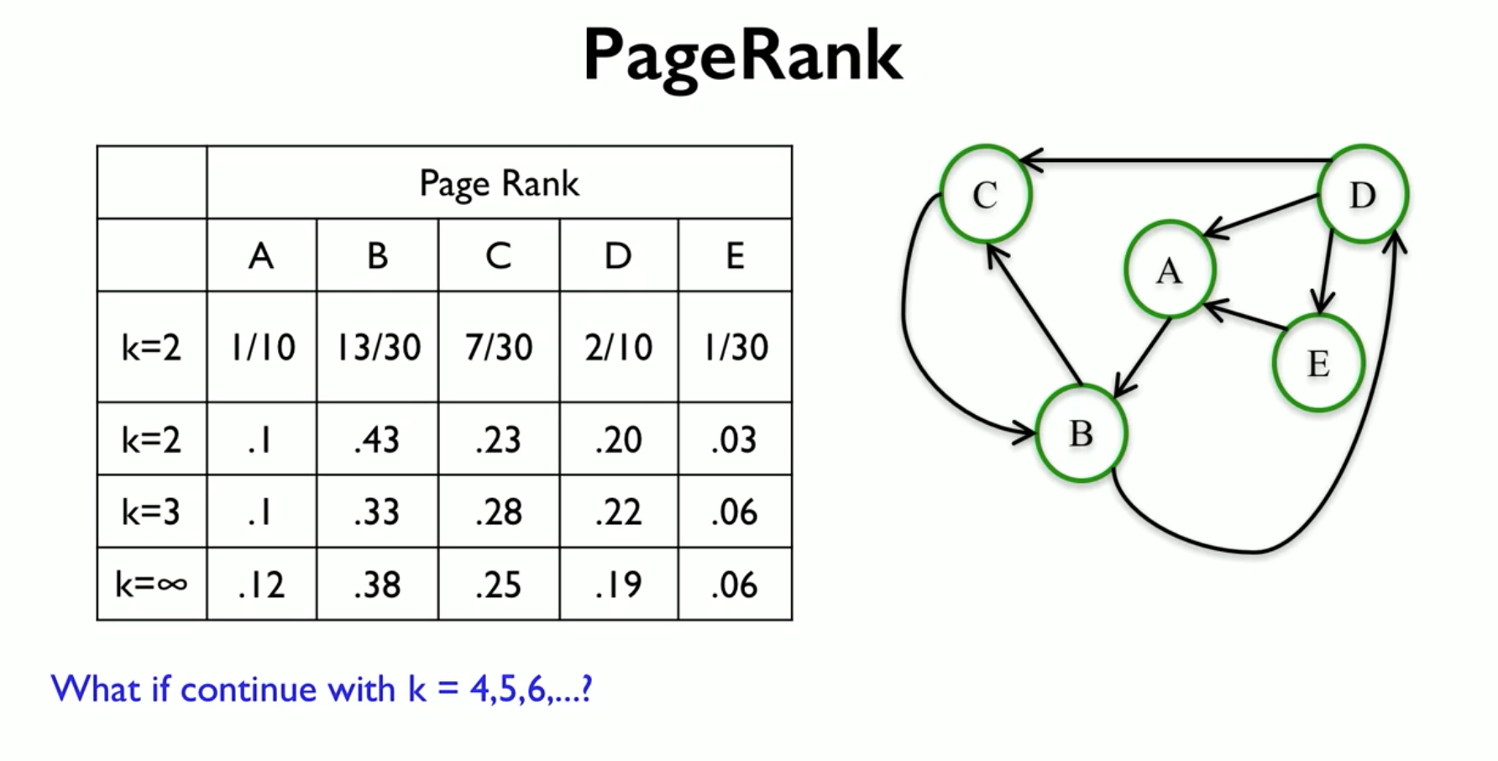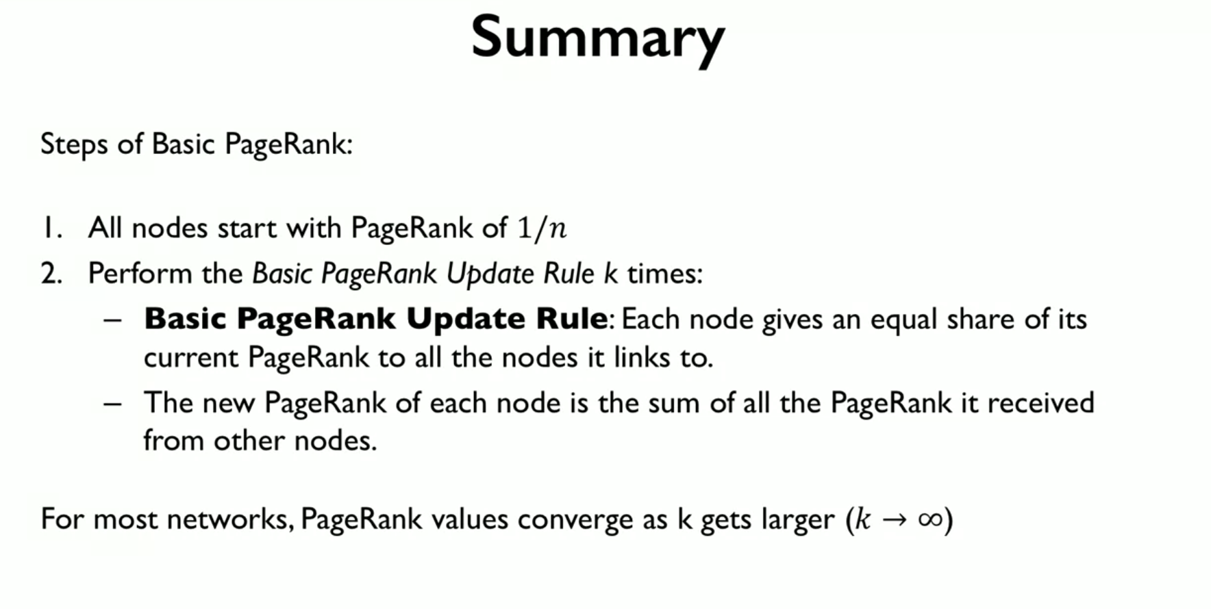

So in summary, the steps of Basic PageRank are the following. First, you start with all the nodes with a PageRank value of 1/n. And then you perform these Basic PageRank Update Rule k times. And this Update Rule said says that every node is going to give an equal share of its current PageRank to all the other nodes that it links to. And so the new PageRank value of every node is going to be simply the sum of all the PageRank that it gets from all the nodes that point to it.

And for most networks, these PageRank values will actually converge as k gets larger, as k goes to infinity. We're going to find that these values converge to a unique value. And so that's how you compute a basic PageRank. And that's all for this video, and I will see you next time.

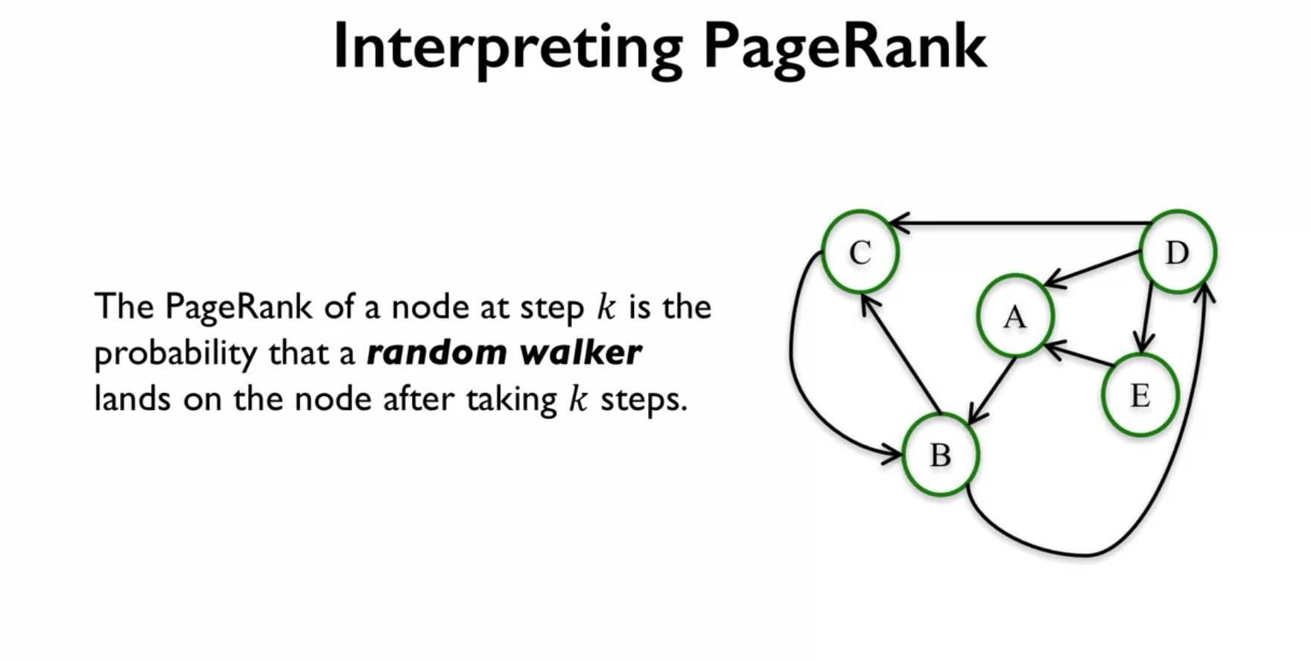

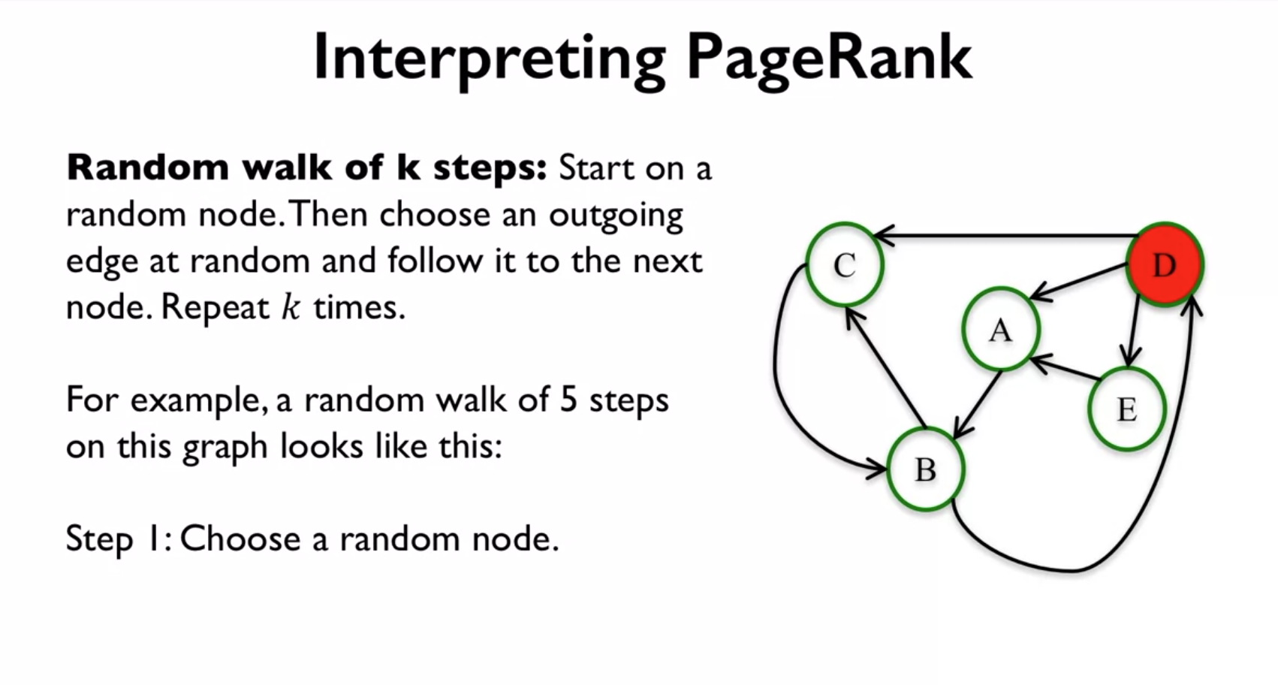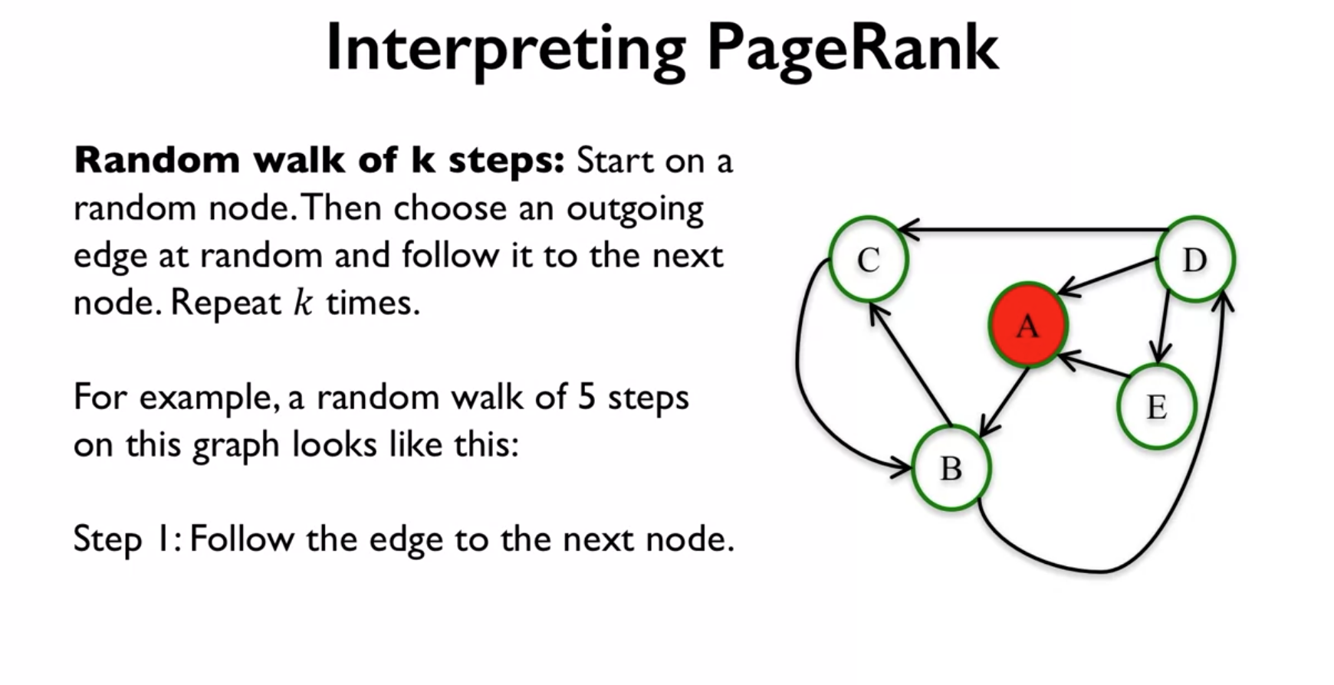

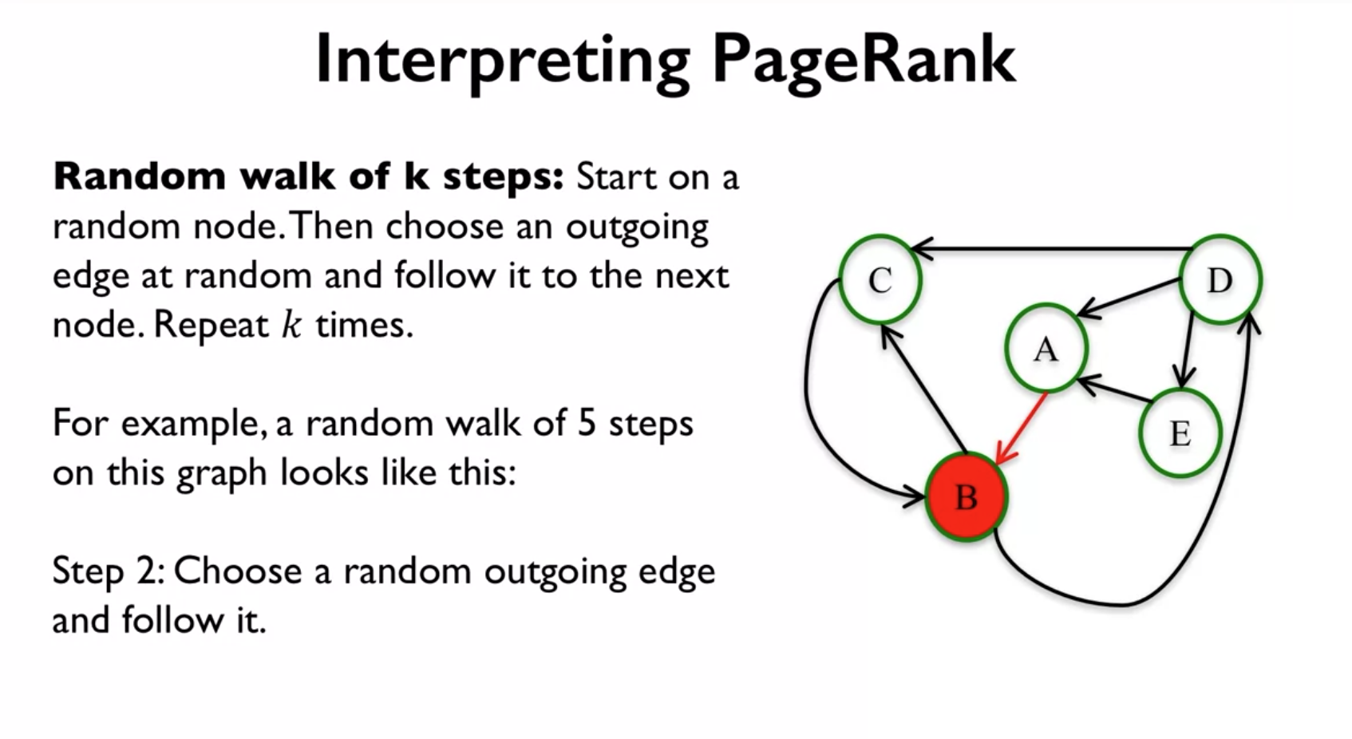

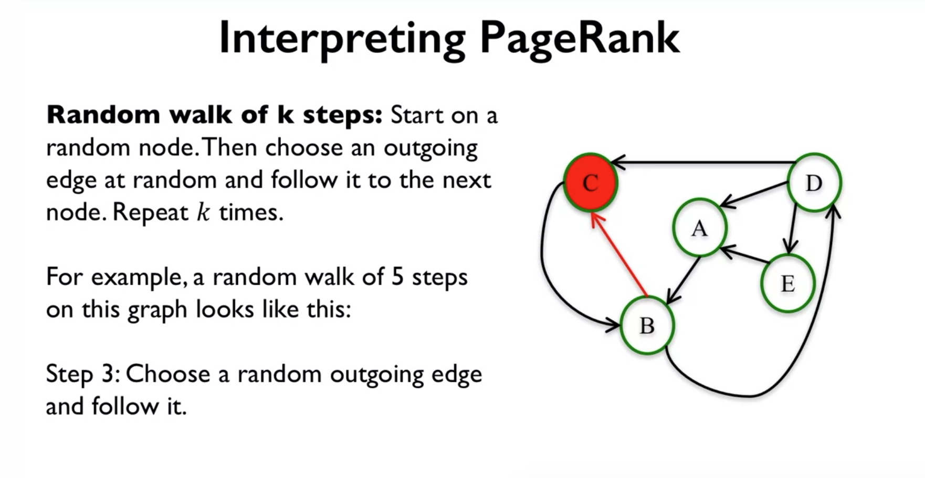

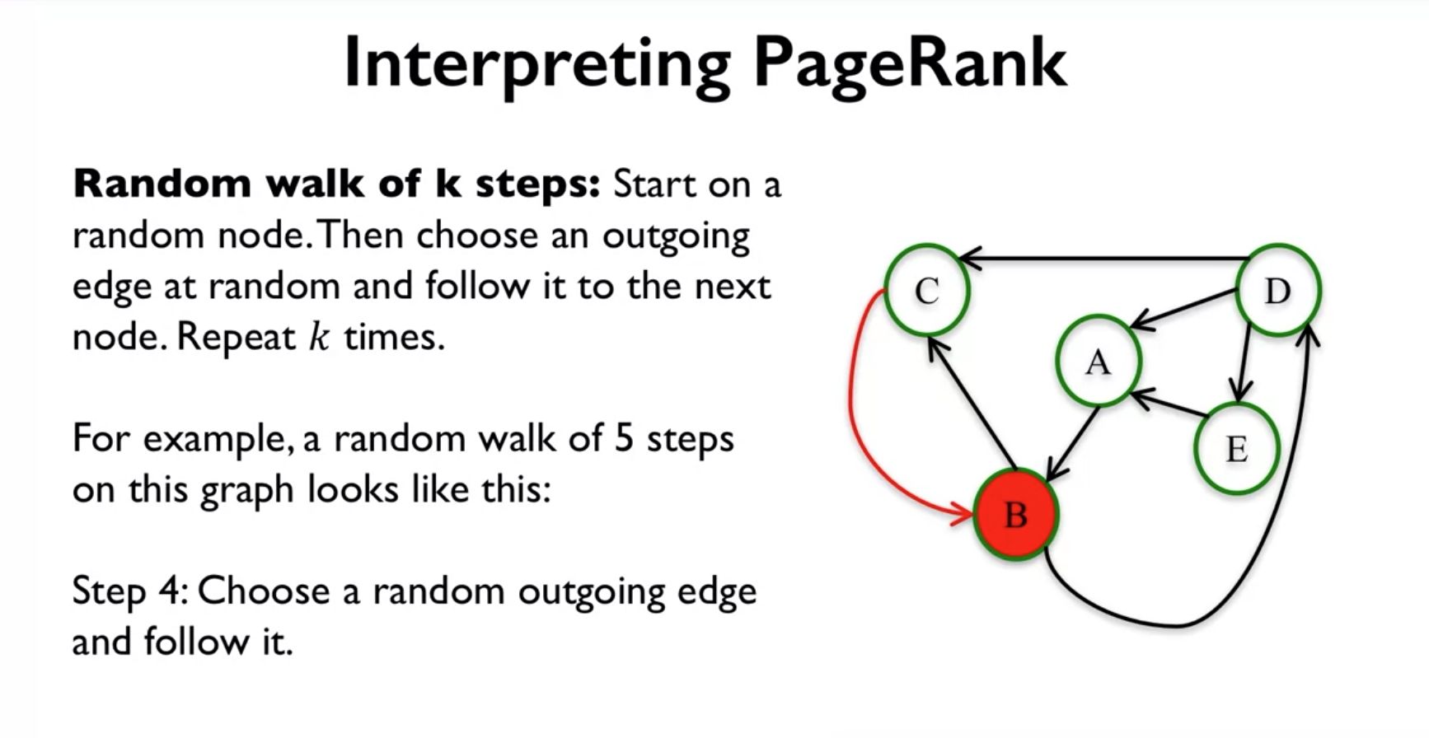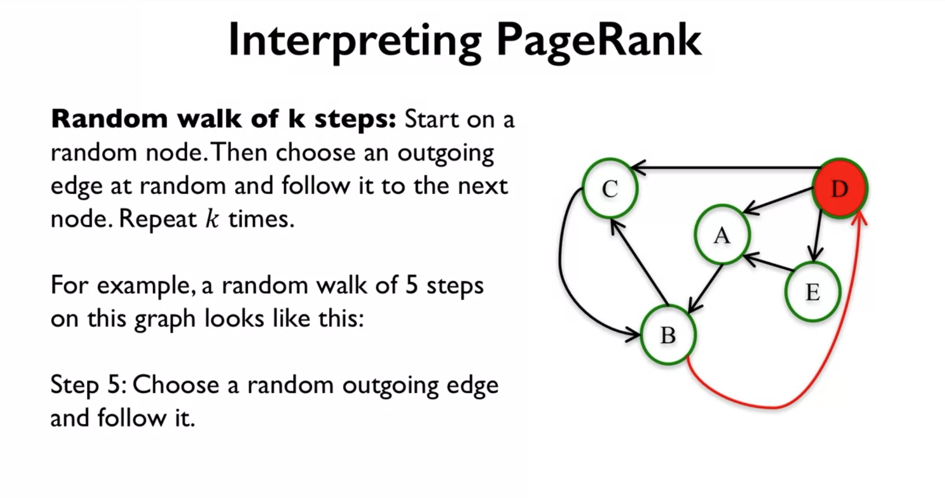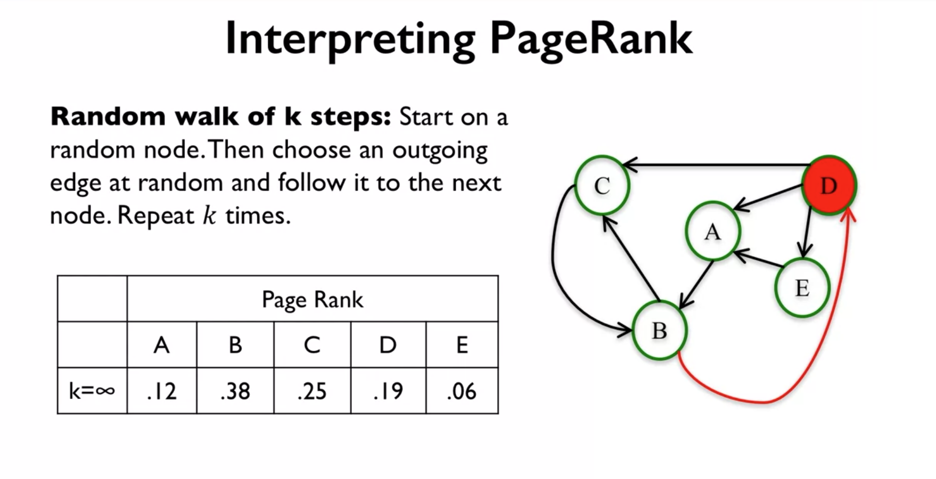

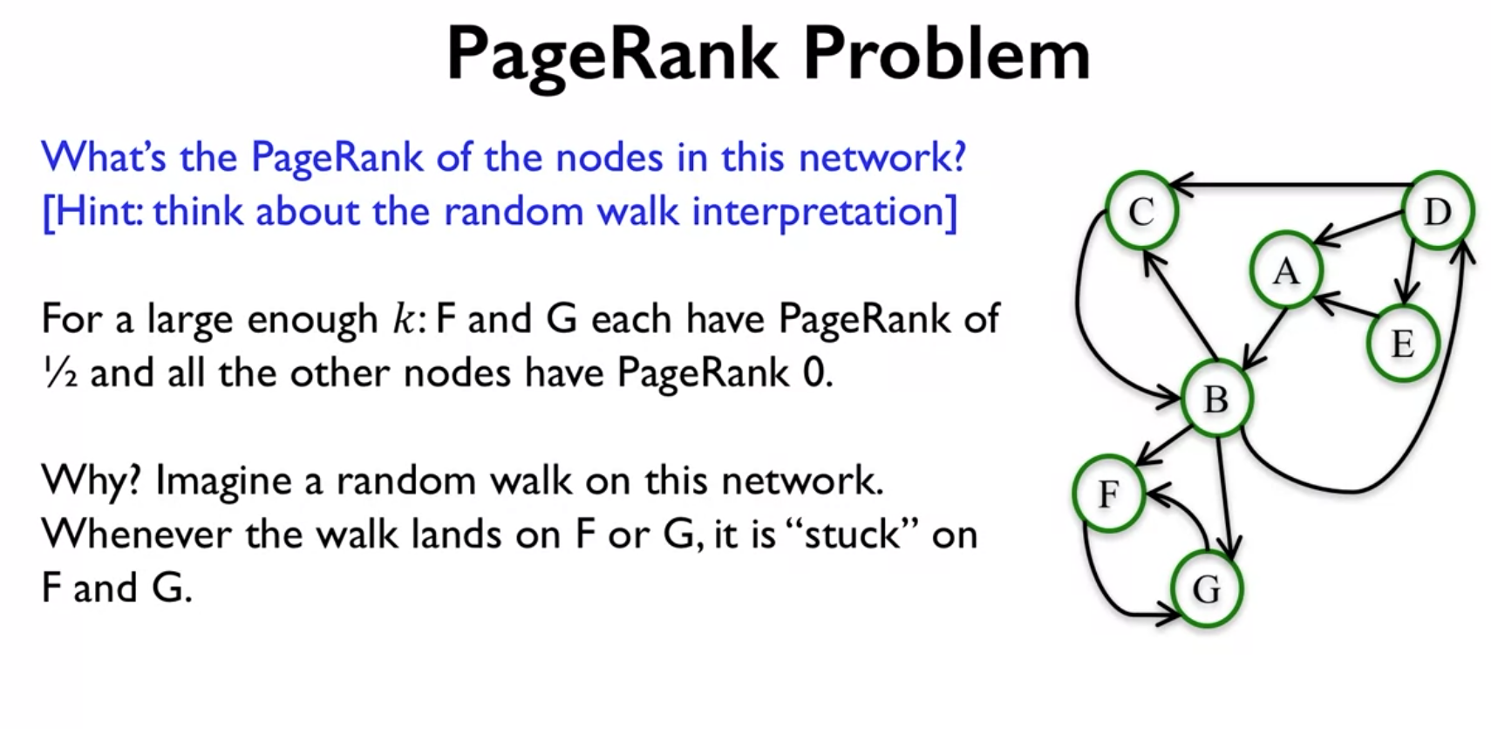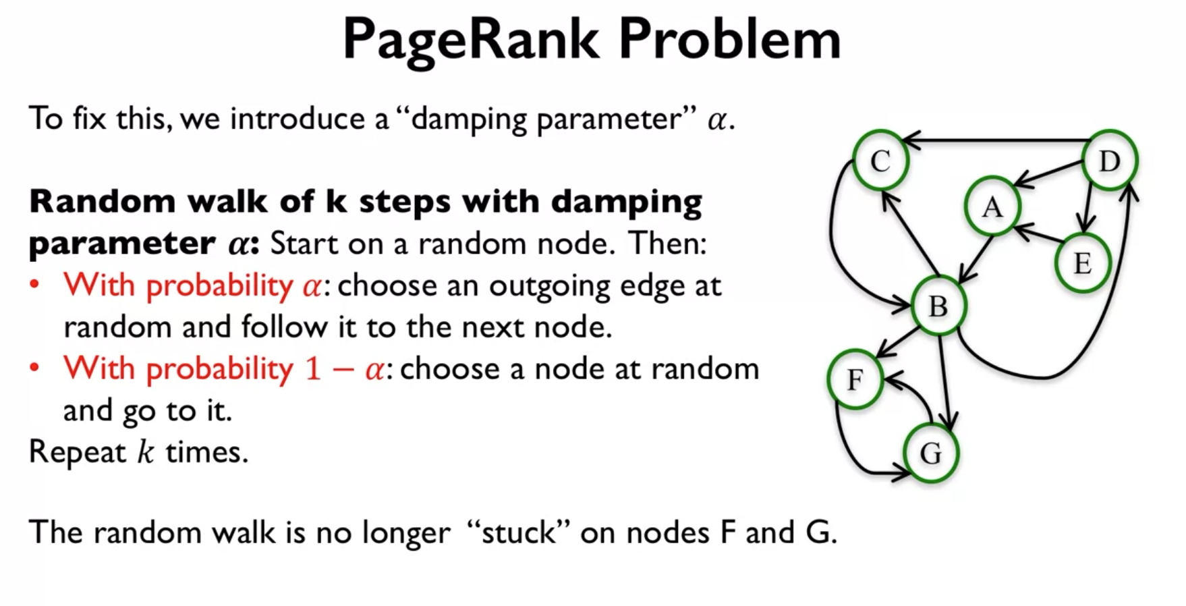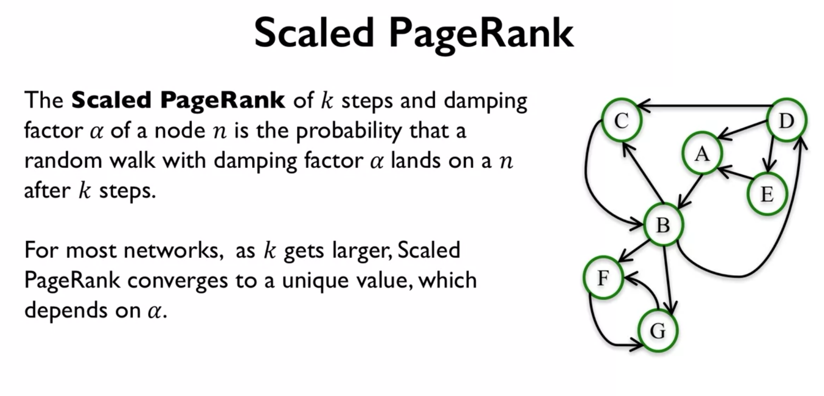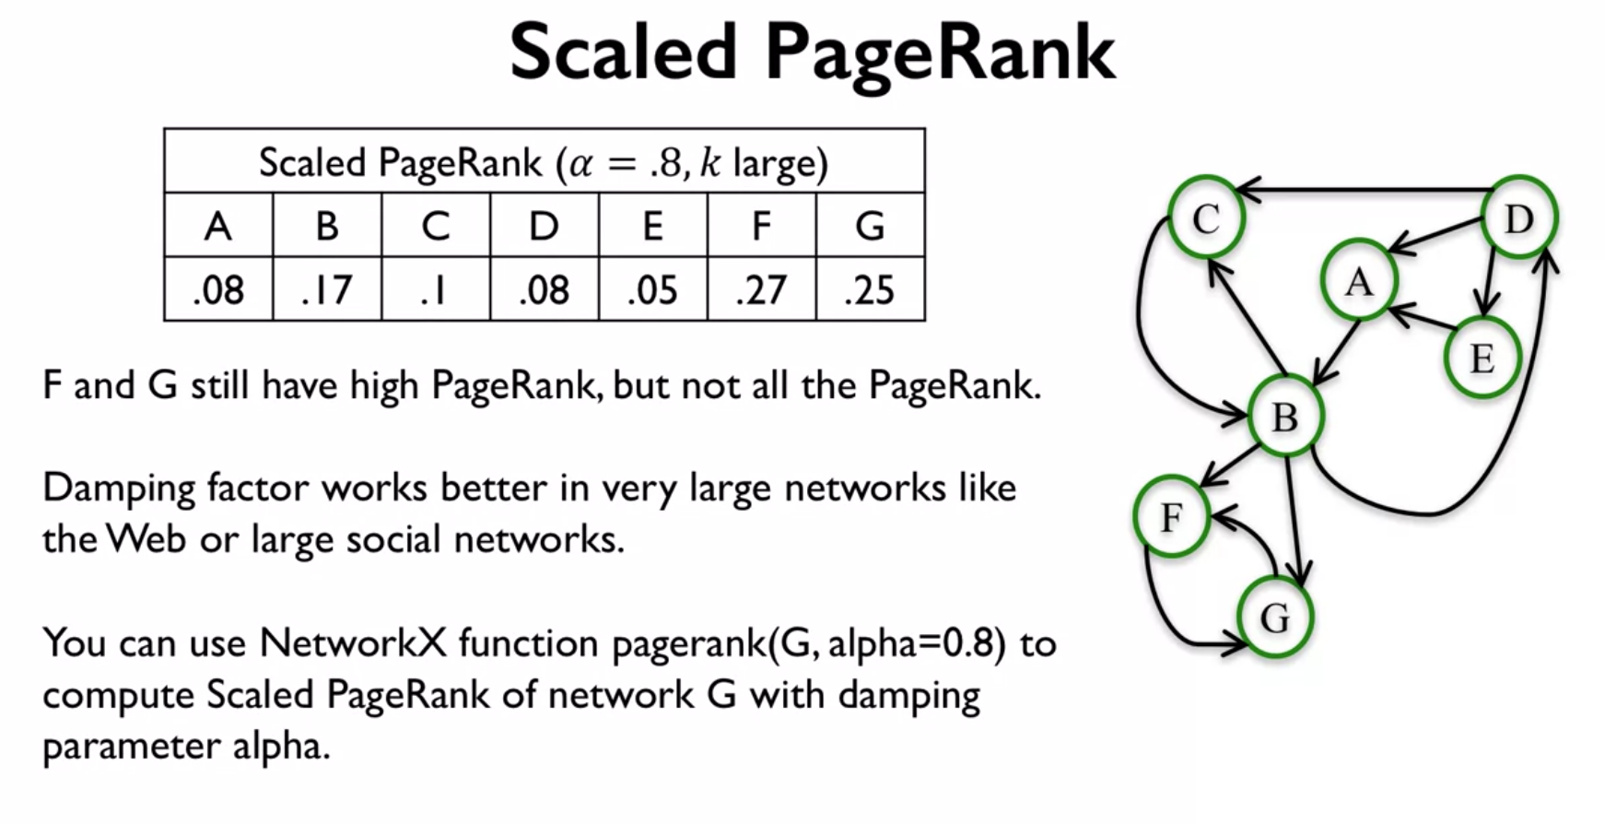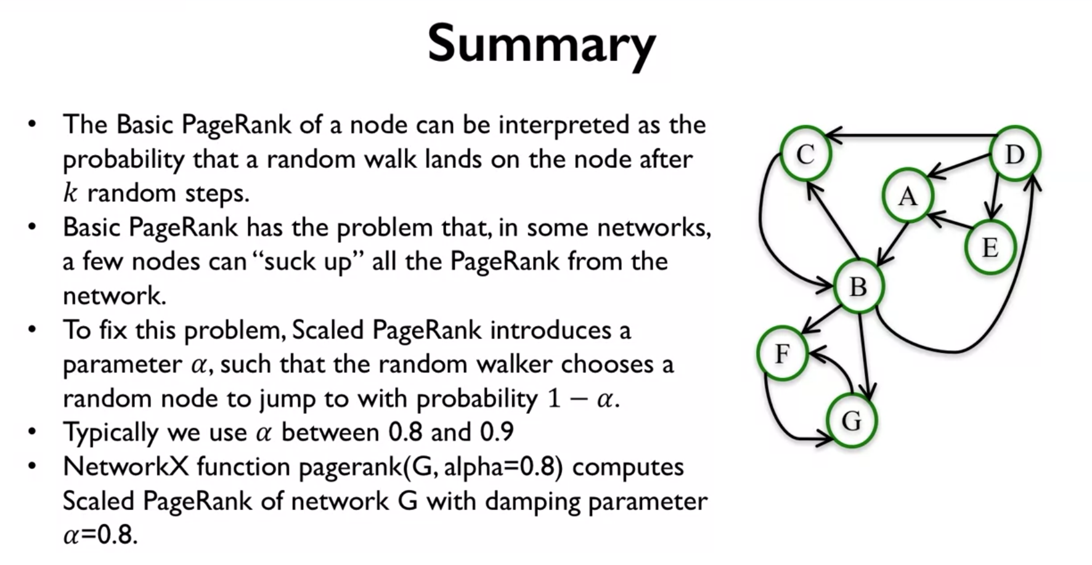

So in summary, what we find is that the basic PageRank of a node can be interpreted as the probability that a random walk lands on that node after k steps. And this is a useful interpretation, because well, it allows us to see this problem that Basic PageRank has. That sometimes for some networks, a few nodes can sort of suck up all the PageRank from all the other nodes in the network. And so to fix this problem, there is this other version of PageRank which is called Scaled PageRank that introduces this parameter alpha. So this random walker chooses a random node to jump to with probability 1- alpha. So, what that does is that it allows the walker to not be stuck anywhere, but sometimes it's sort of jumping randomly. And typically, we use a perimeter alpha between 0.8 and 0.9. But we do have to keep in mind that the PageRank value that we get will depend on the particular choice of alpha. And to compute this or to use this in NetworkX, you can use the function PageRank with input parameters G, the network, and then the alpha that you want, to compute the Scaled PageRank with the network G with damping parameter alpha. And that's all for today, and I hope to see you next time.

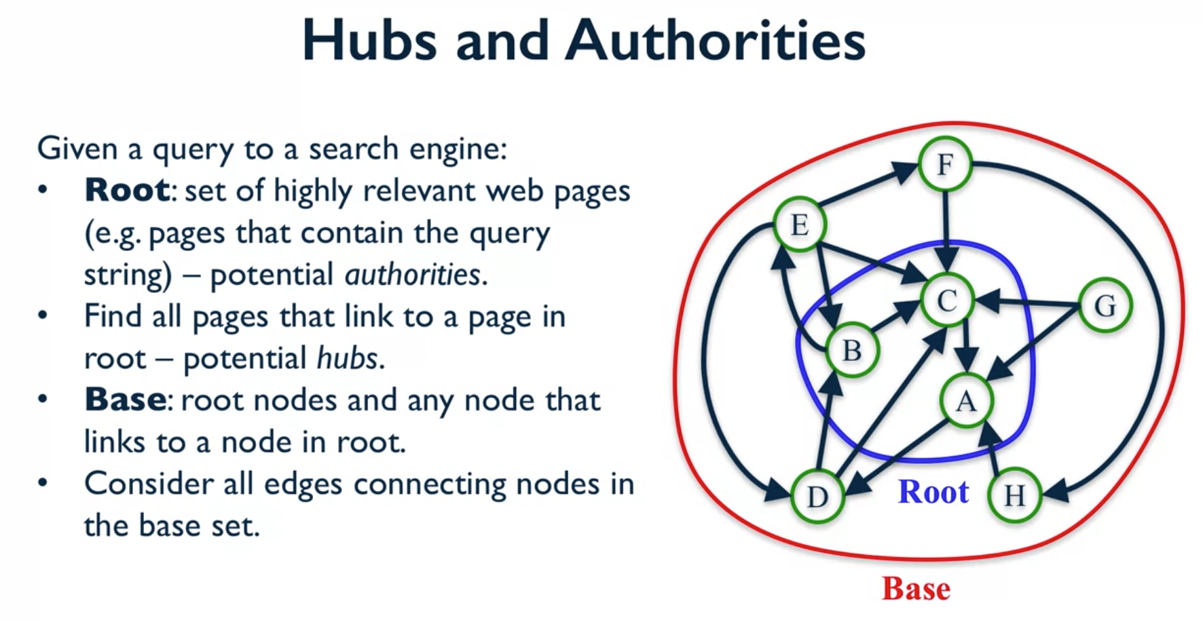

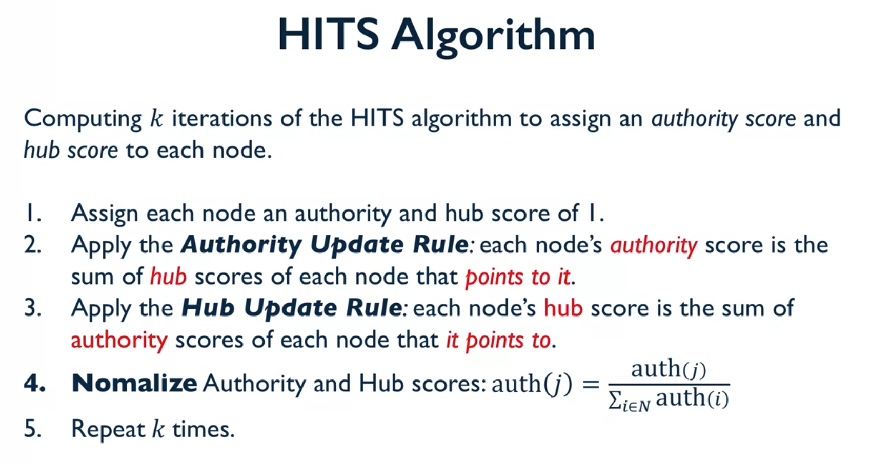

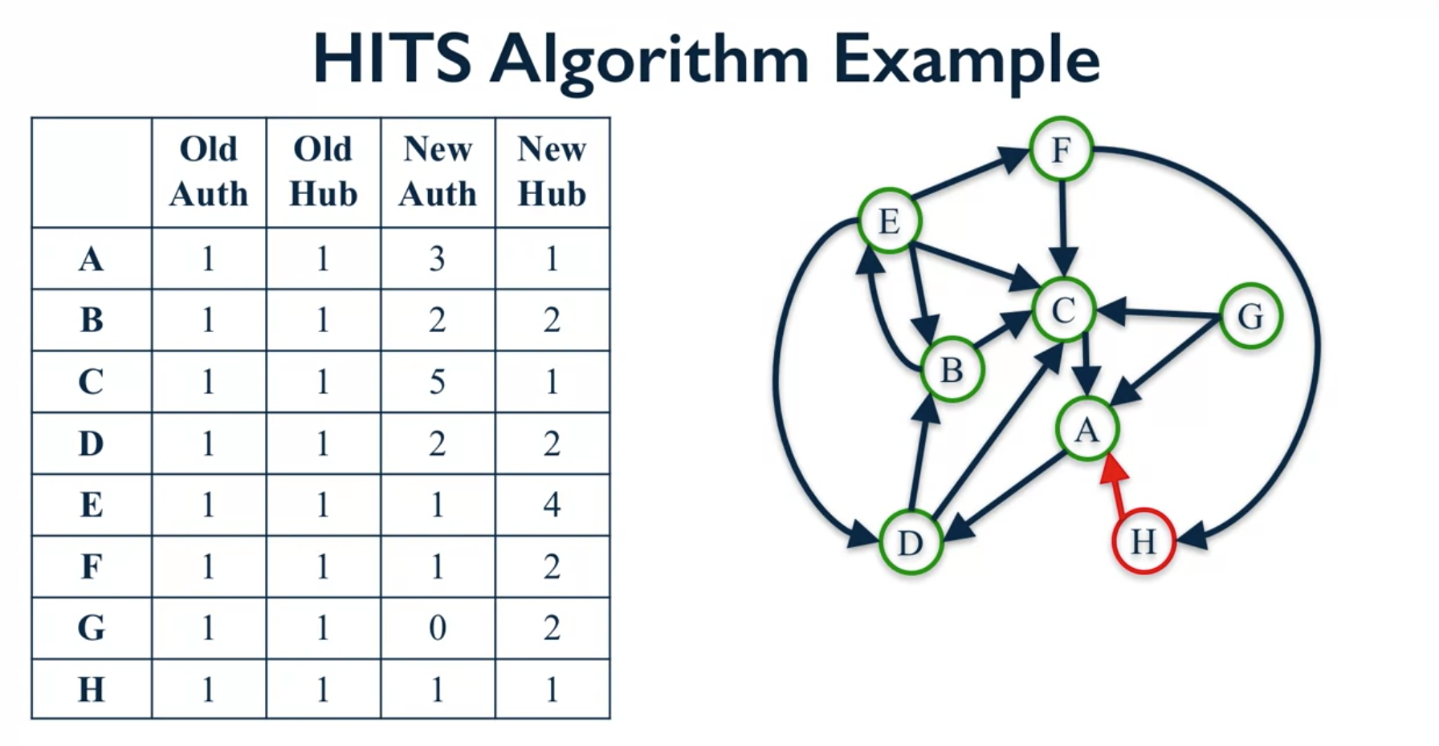

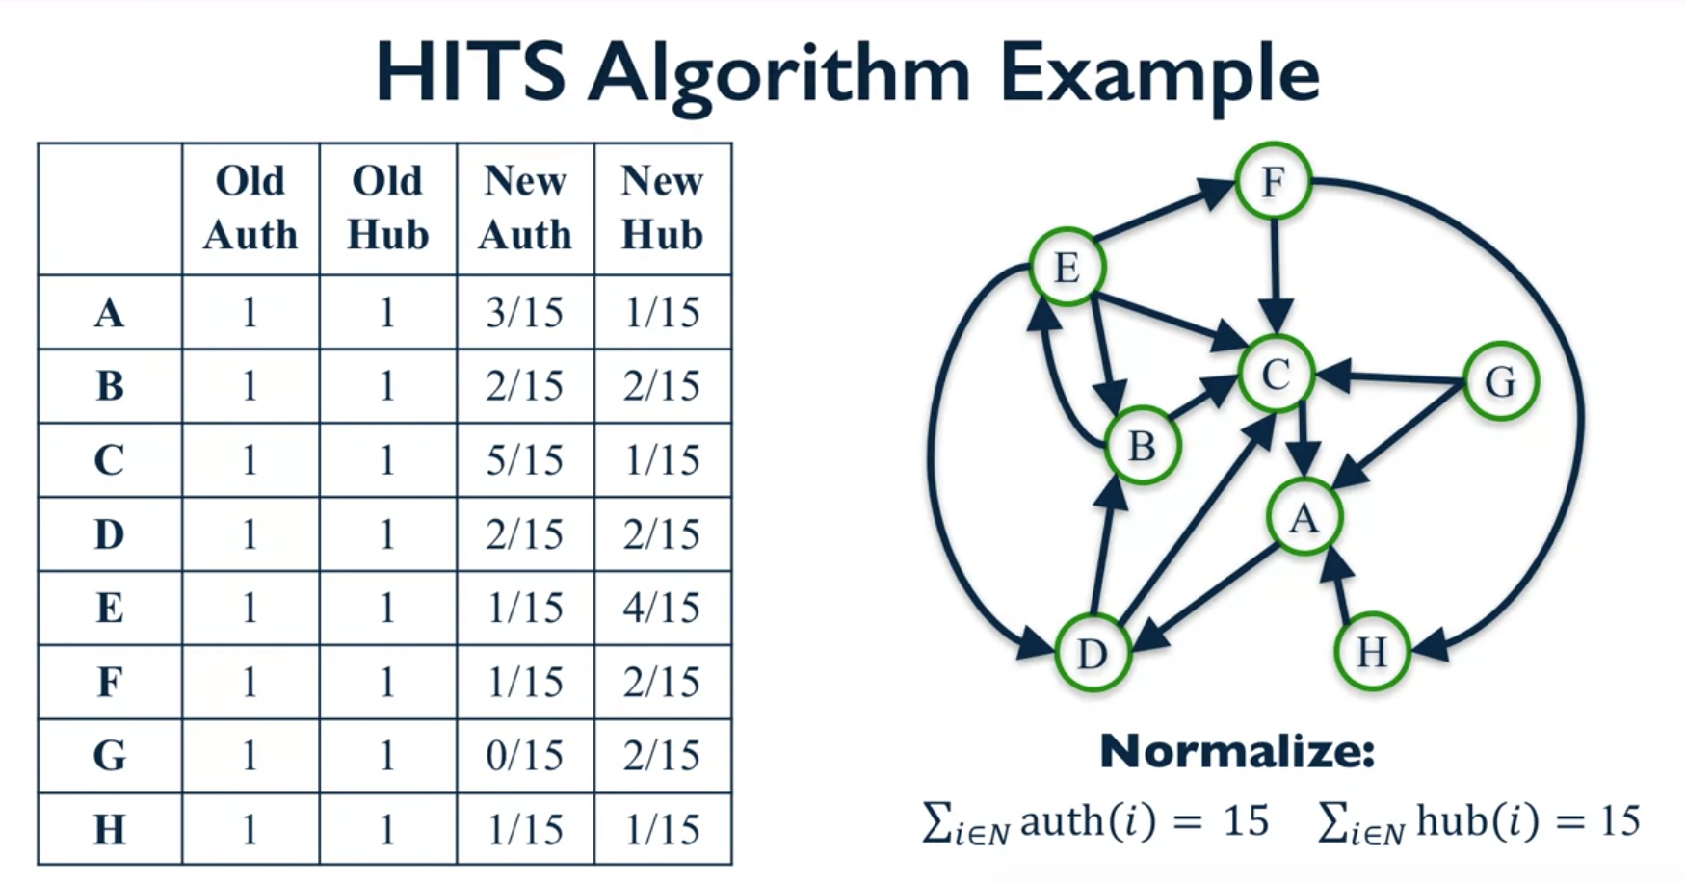

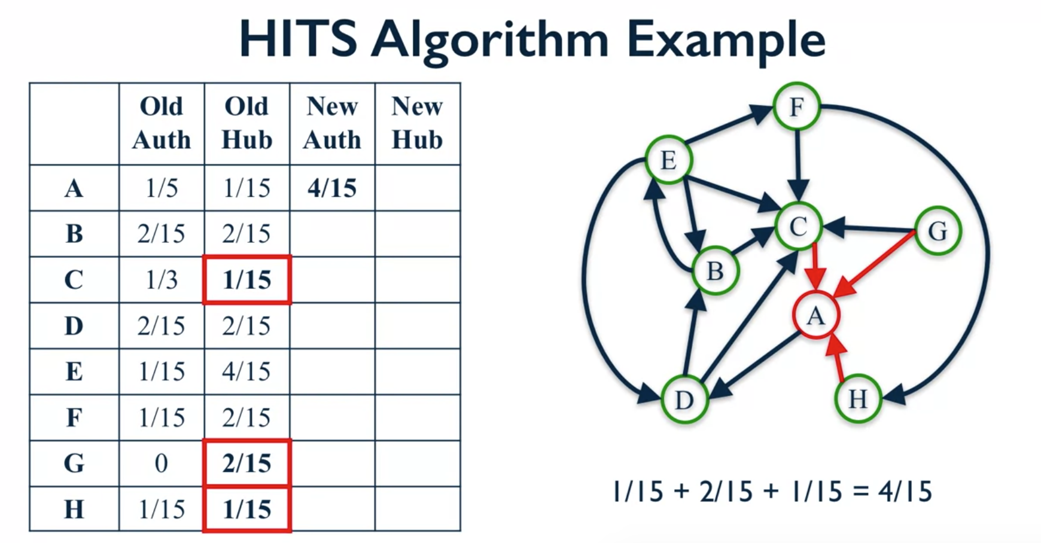

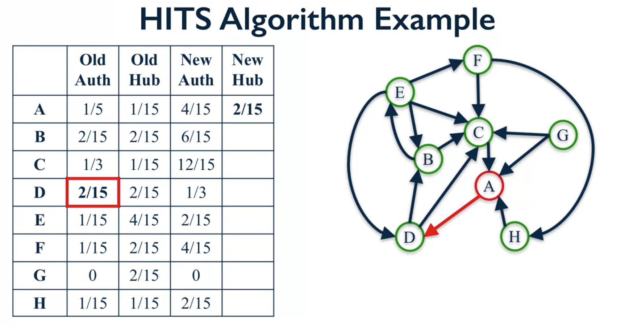

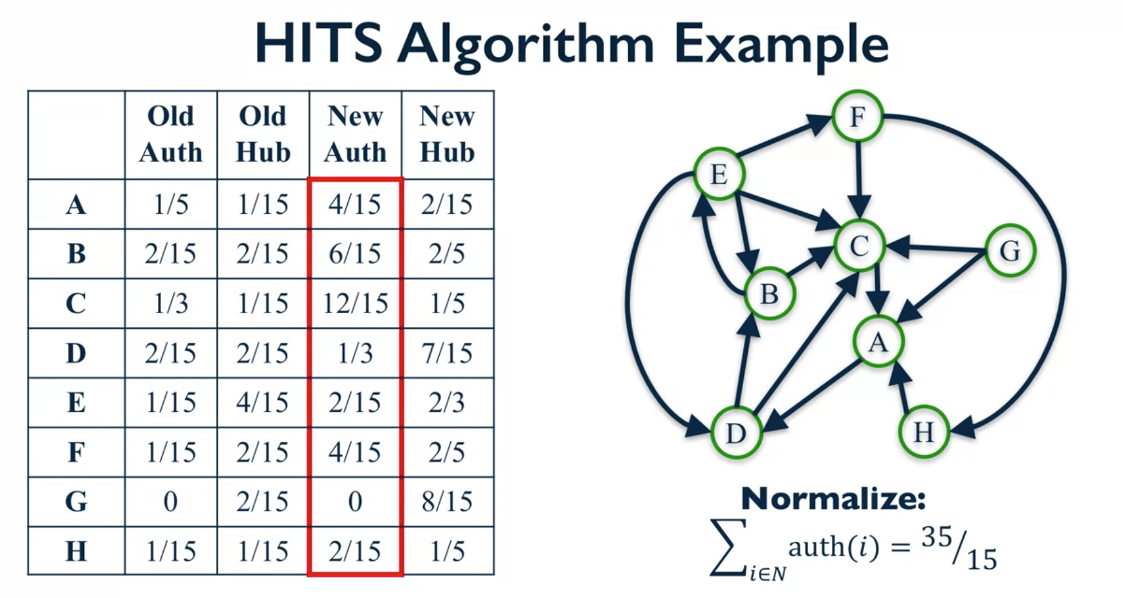

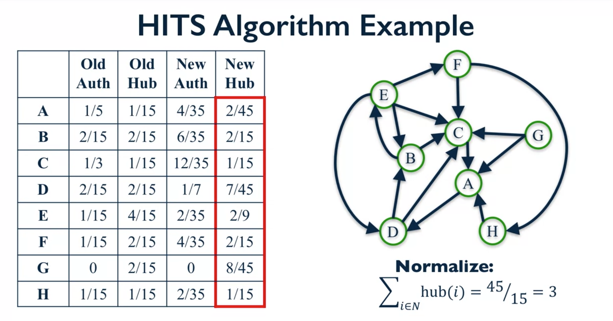

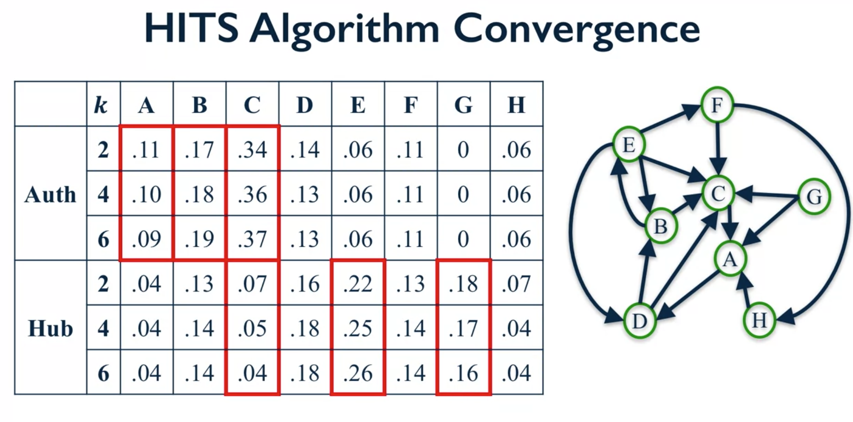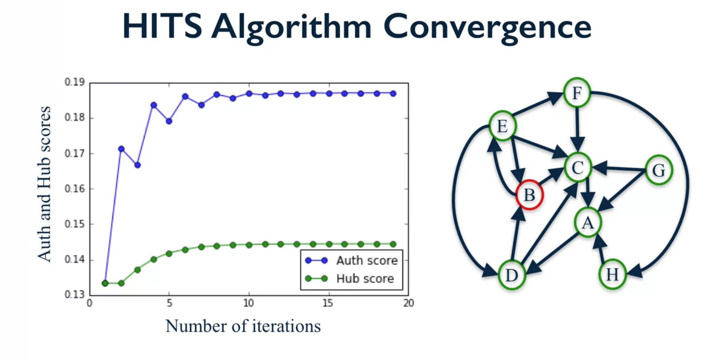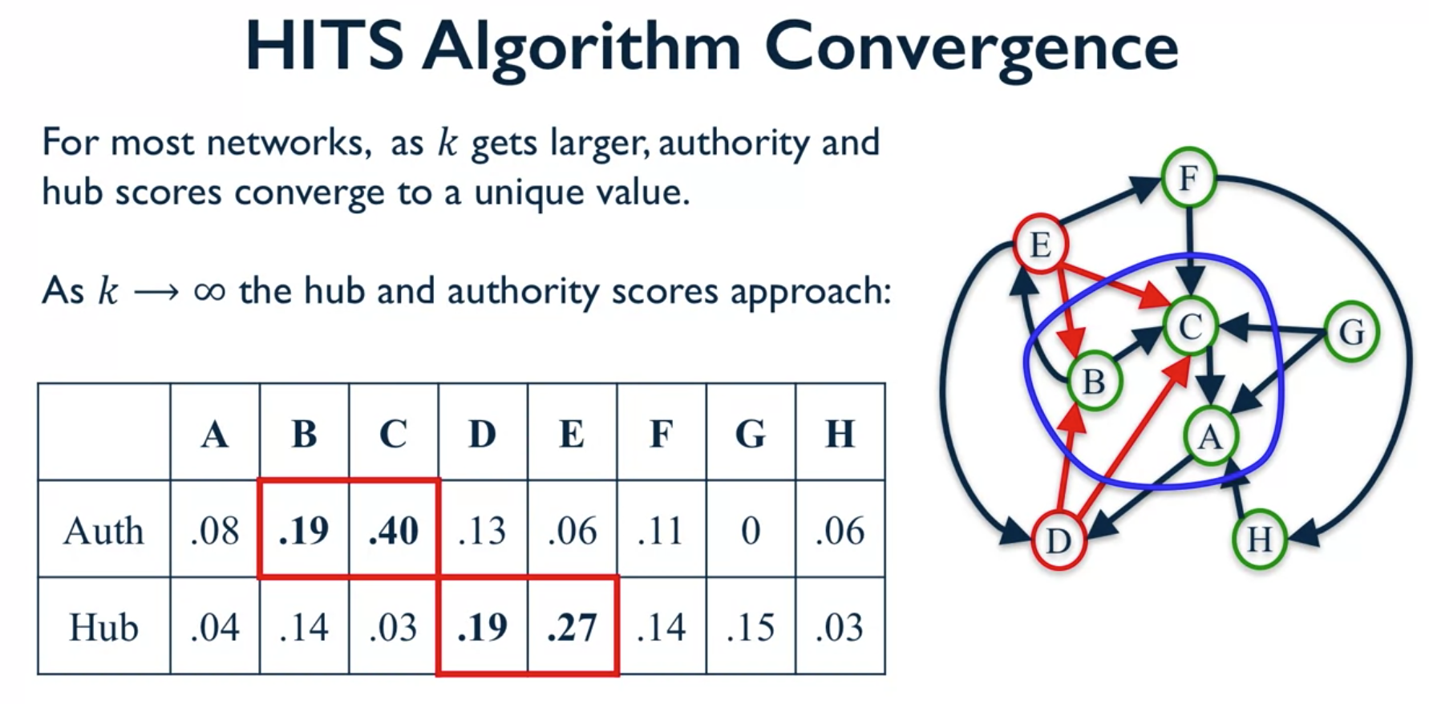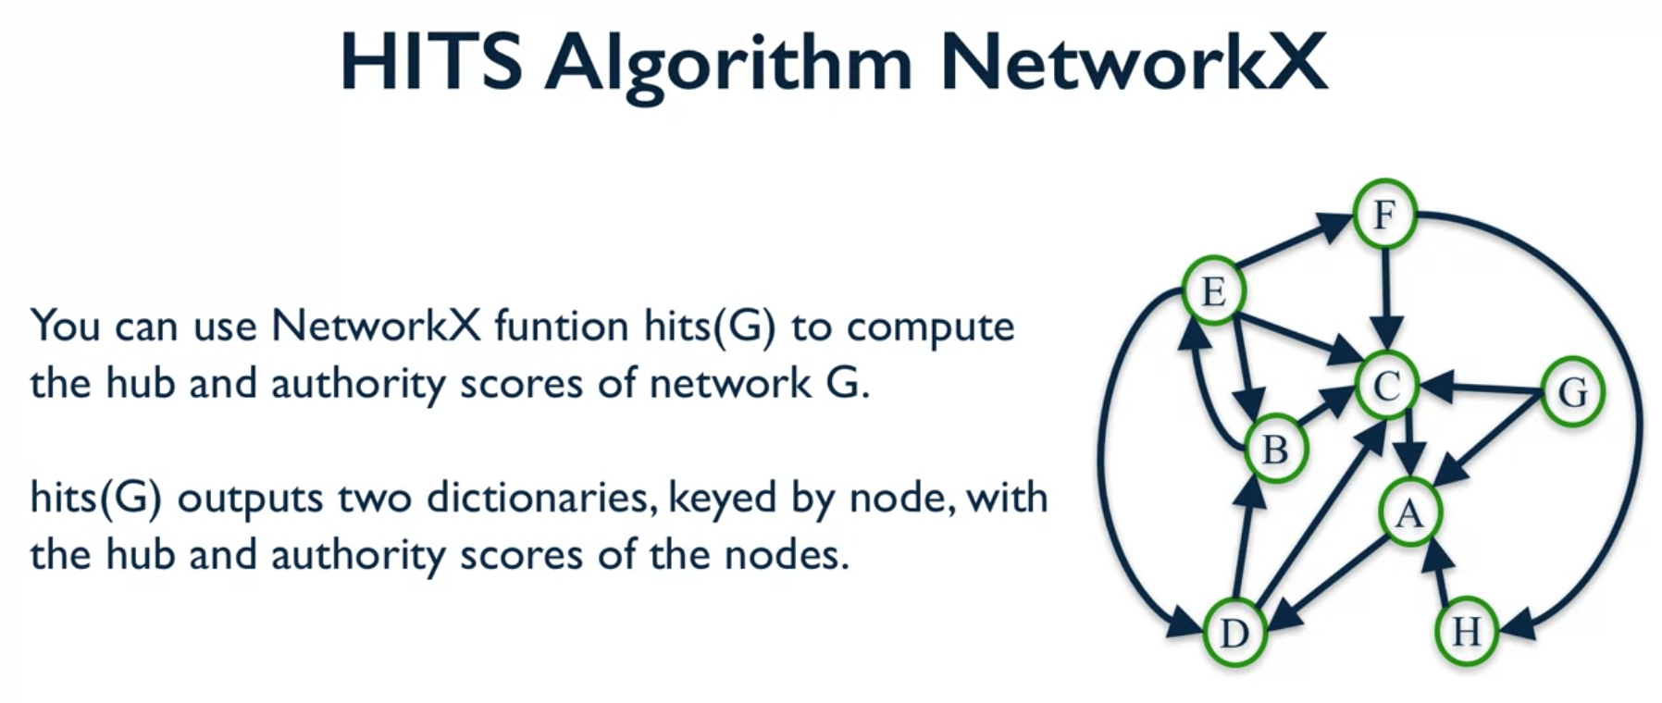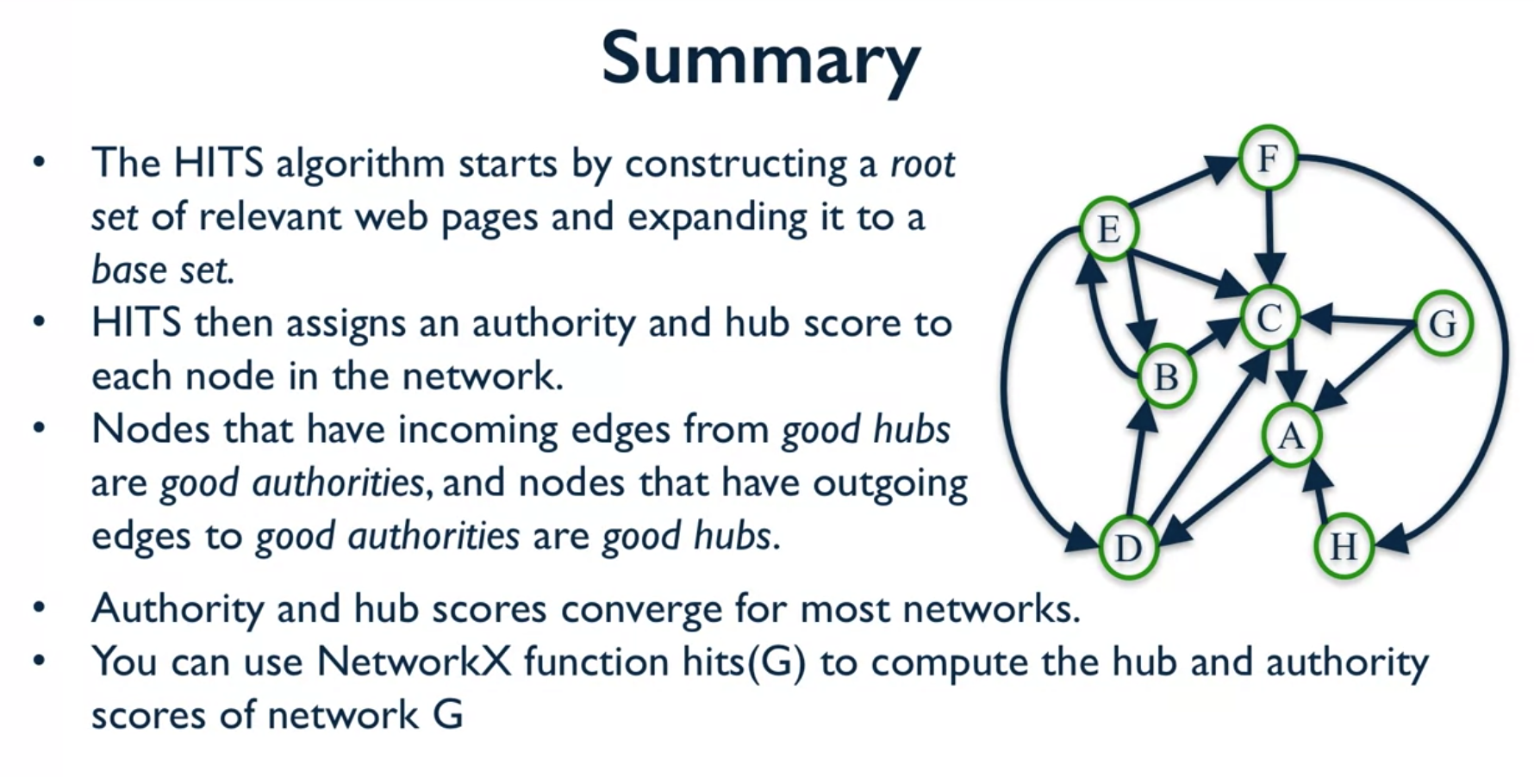

And here, nodes that have incoming edges from good hubs are thought to be good authorities, and then nodes that have outgoing edges to good authorities are thought to be good hubs. Authority scores and hub scores for most networks will converge to a unique value. And you can use NetworkX to find the scores by using the function hits on any network that you want to. And that is all for this video, and I will see you next time.

